Edusite Lanka

PROJECT REPORT

Edusite Lanka

**Table of contents**

1. Introduction ------------------------------------------------------- 02

2. Objectives and Functional requirements of the website ---- 03

3. Design of the website -------------------------------------------- 05

4. Implementation --------------------------------------------------- 14

5. Tools used in the design and development of the website -- 40

6. Initial plan vs. actual plan --------------------------------------- 41

7. Work contribution table ----------------------------------------- 42

8. Details of group members --------------------------------------- 44

**INTRODUCTION**

Education is a fundamental right of every individual, and the quality of education plays a significant role in shaping a person's future. However, in today's fast-paced world, traditional educational systems are not always enough to meet the diverse needs of students. Many students require additional help and support to excel in their studies, and tutoring is an effective way to provide this assistance.

The tutoring website project aims to develop a platform that connects students with experienced tutors and provides them with the resources and tools they need to succeed academically. The website is designed to be user-friendly and accessible to students of all ages and backgrounds, providing them with a virtual learning environment that is both safe and engaging.

This project report will detail the process of developing and implementing the tutoring website, including the objectives, methodologies, and technologies used. The report will also discuss the key features and functionality of the website, such as the tutor search engine, the online classroom environment, and the registration and login system.

Finally, the report will outline plans for future development and enhancements to the website, ensuring it remains a valuable and relevant resource for students for years to come.

Overall, this project report will serve as a comprehensive guide to the development and implementation of a modern, effective, and user-friendly tutoring website that aims to improve the academic outcomes of students countrywide.

**OBJECTIVES AND FUNCTIONAL REQUIREMENTS OF THE WEBSITE**

**OBJECTIVE**

*The main target of this website is to connect students who need online and physical tuition in Sri Lanka with talented tutors.*

• To provide a user-friendly platform that allows students to easily search for tutors based on subject, level of education, and location.

• To ensure that all tutors on the platform are qualified, experienced, and have passed a thorough background check.

• To offer a variety of tutoring options, including in-person, online, group sessions, and one-on-one sessions.

• To provide tools for students and tutors to communicate and collaborate effectively, such as scheduling tools, messaging systems, and progress tracking.

• To ensure that the pricing for tutoring services is competitive and transparent.

• To provide a platform where tutors can easily connect with potential students and grow their business.

• To offer tools for tutors to manage their schedules, communicate with students, and track their progress.

• To ensure that tutors are paid fairly and on time for their services.

• To provide a supportive community where tutors can connect with other professionals in their field and share knowledge and resources.

• To collect feedback from tutors in order to continuously improve the platform and the services it

We have created our website including 8 + web pages where each page has a different purpose.

* Home page (Index.php)
* Staff page (Staff.php)
* Login page

1. Tutor login page (TeachLogin.php)
2. Student login page (Login.php)

* Register page

1. Tutor register page (Teach_Register.php)
2. Student register page (Register.php)

* Subject pages

1. Mathematics page (Maths.php)
2. Science page (Science.php)
3. ICT page (Ict.php)
4. English page (English.php)

. . . . . . . . . +add more

* Tutor profile page (Sample.php)
* Tutor Update profile page (teach_update_profile.php)
* Student Update profile page (update_profile.php)
* Tutor Registration form page (Tutor_reg.php)

**DESIGN OF THE WEBSITE**

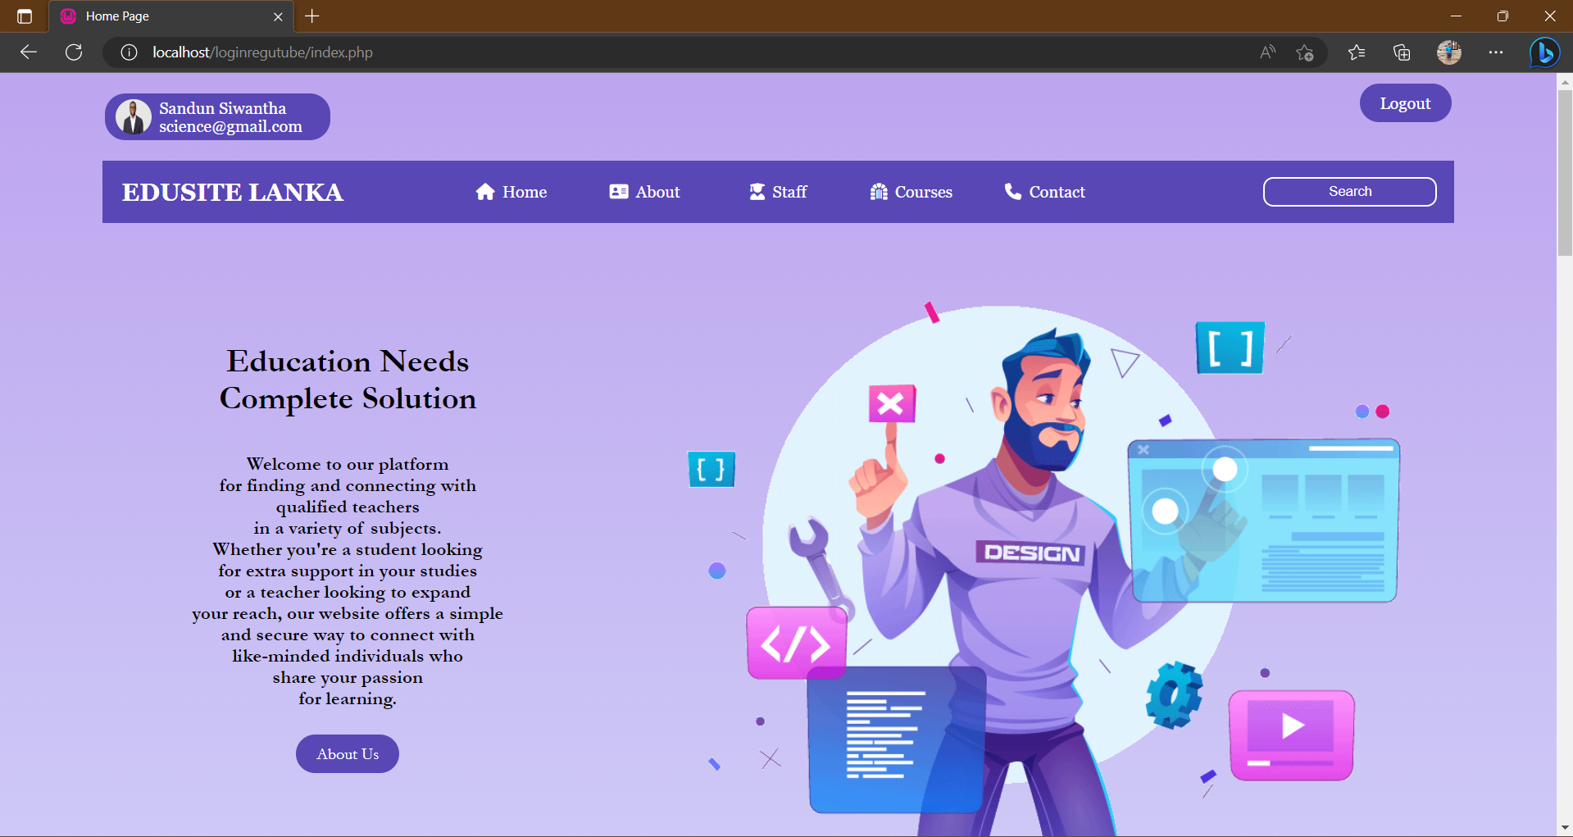

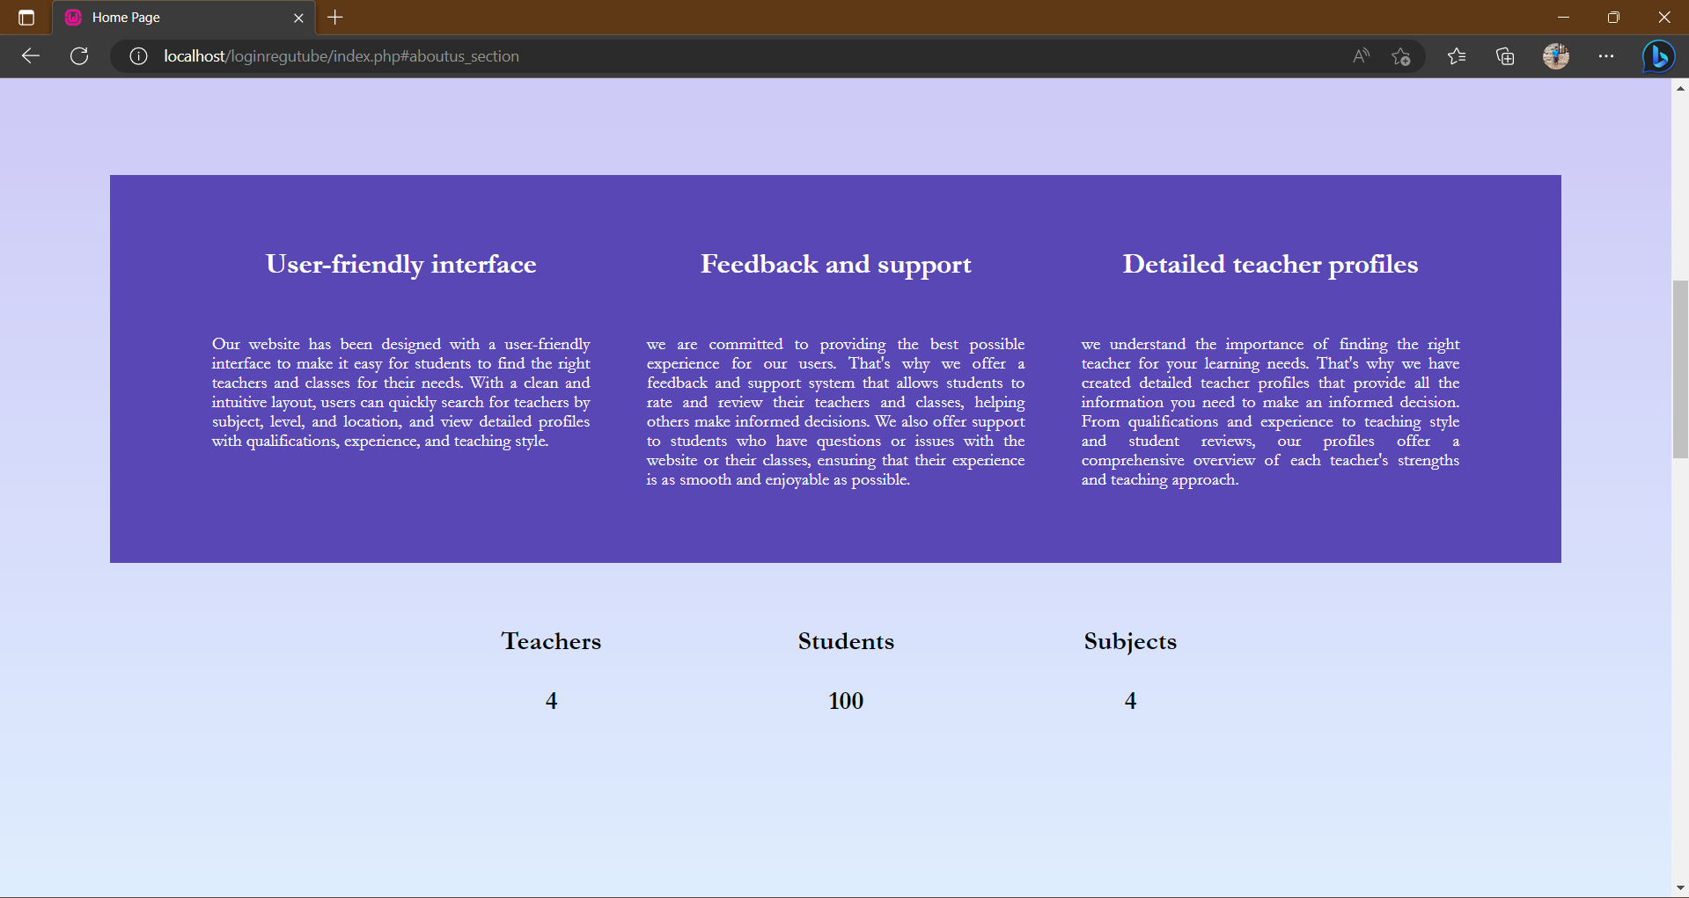

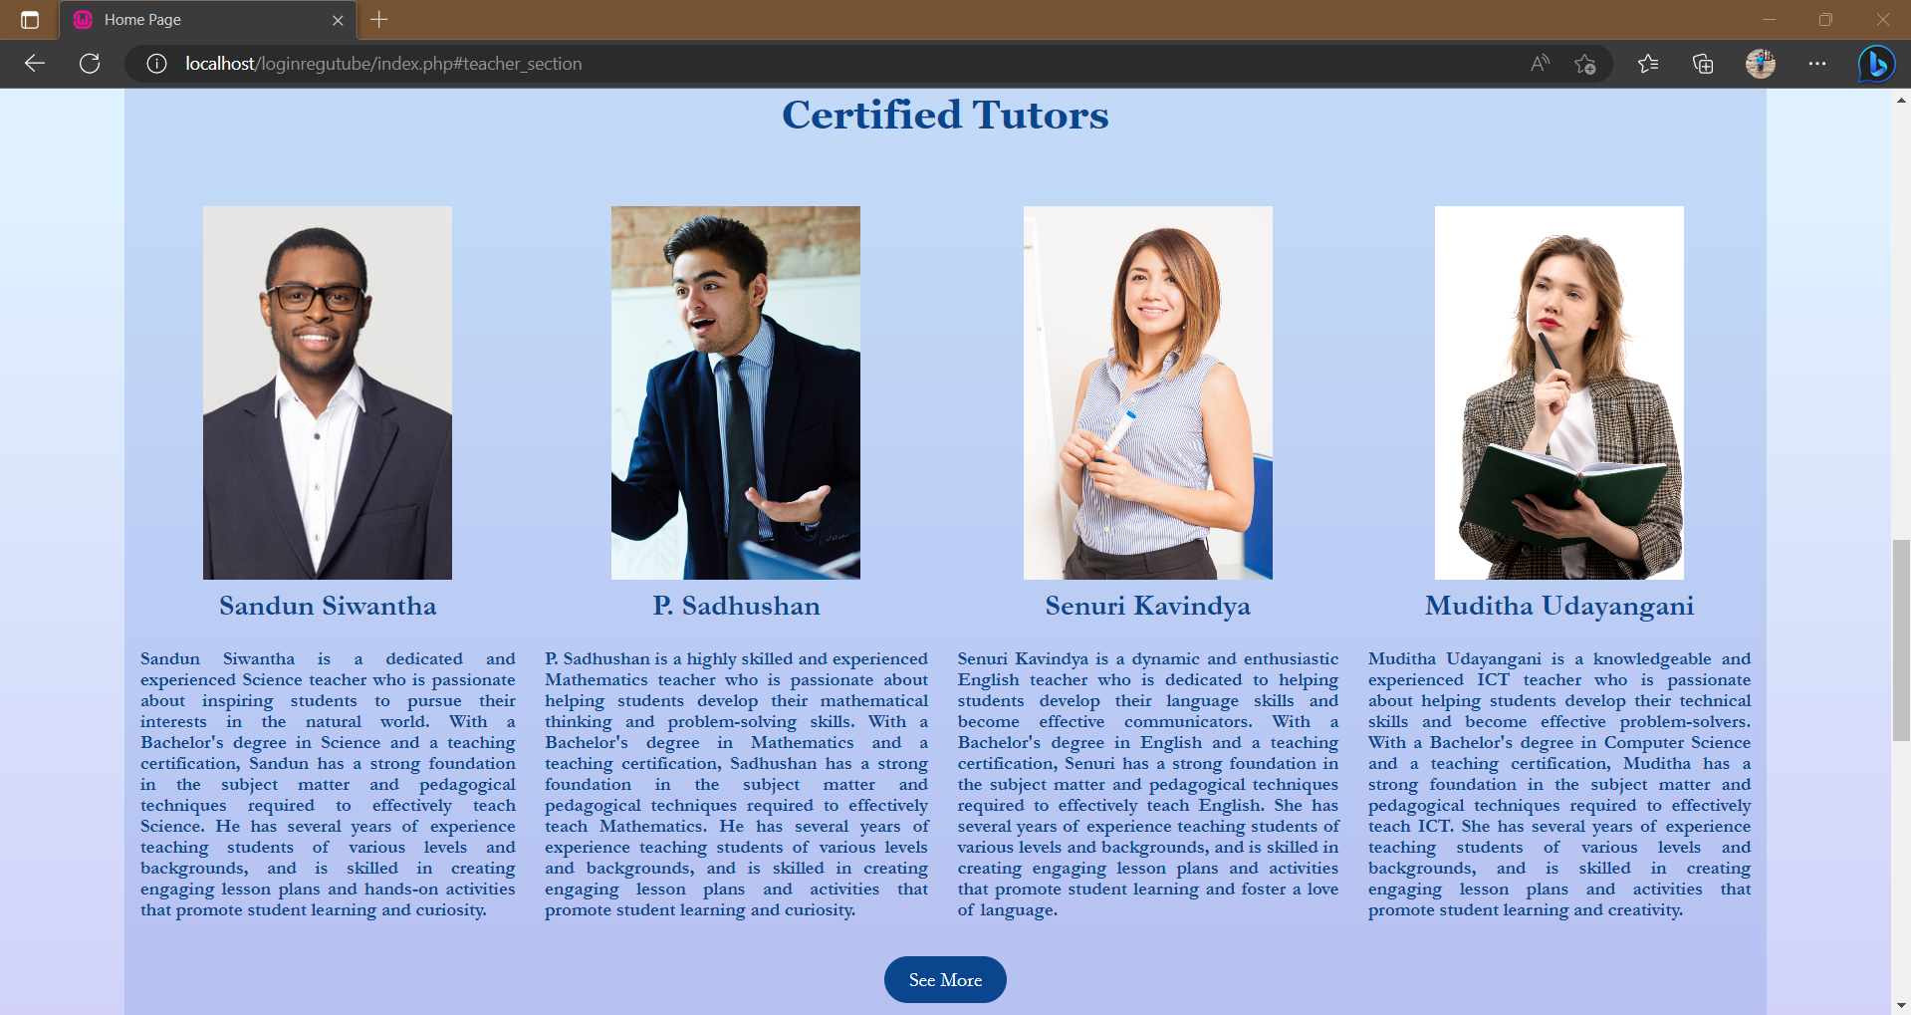

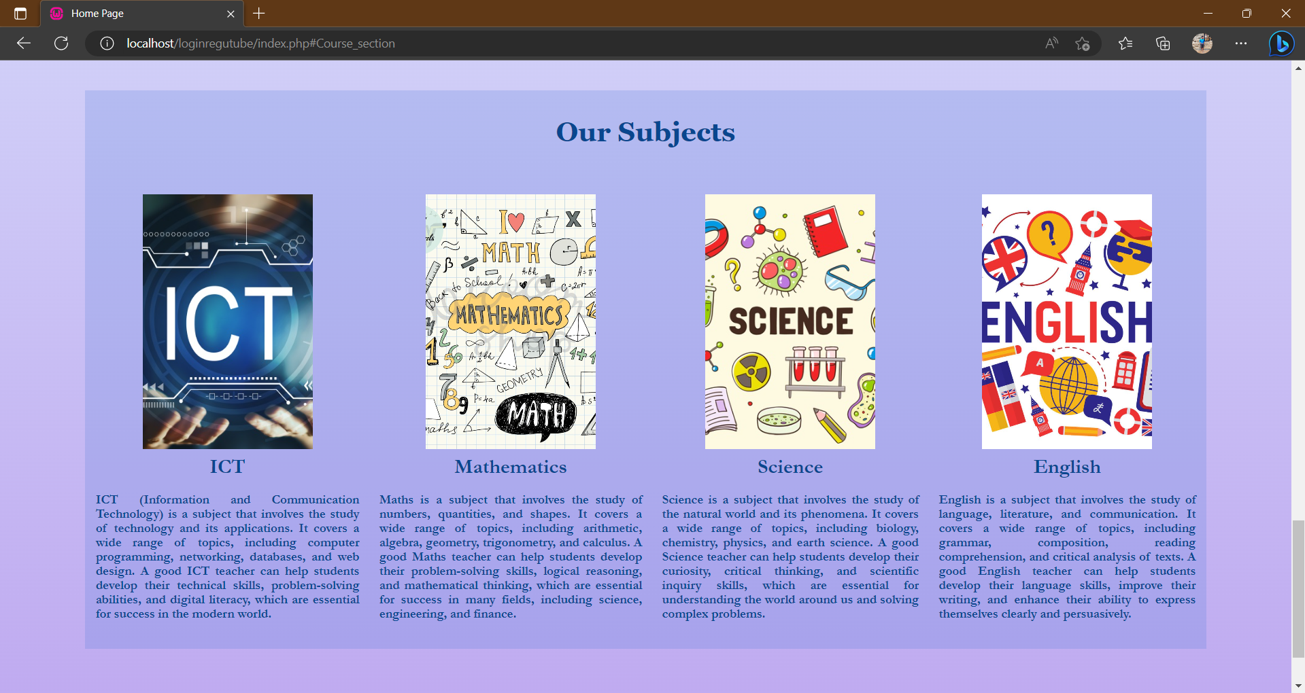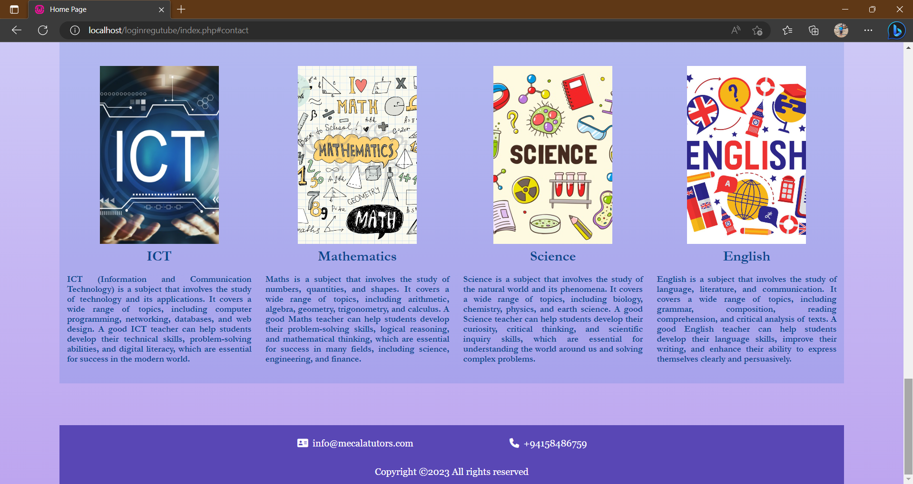

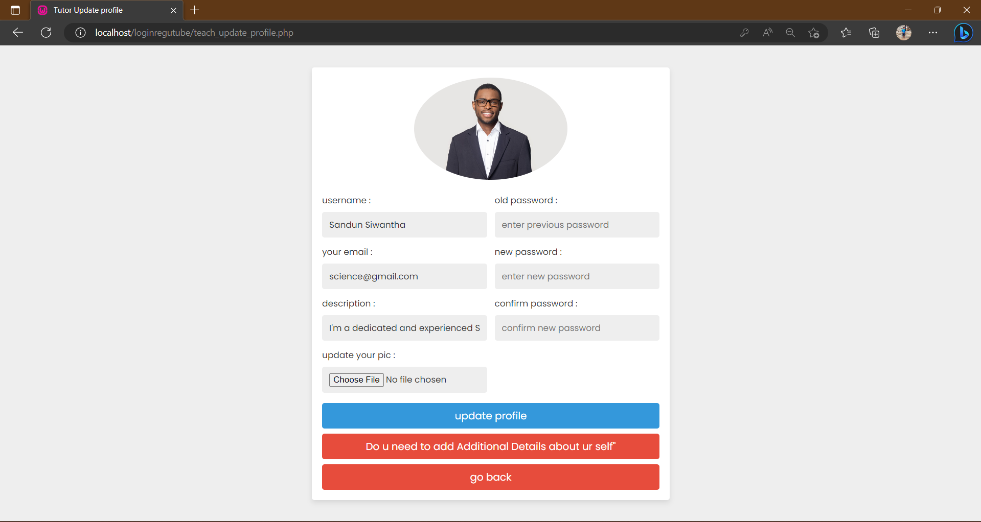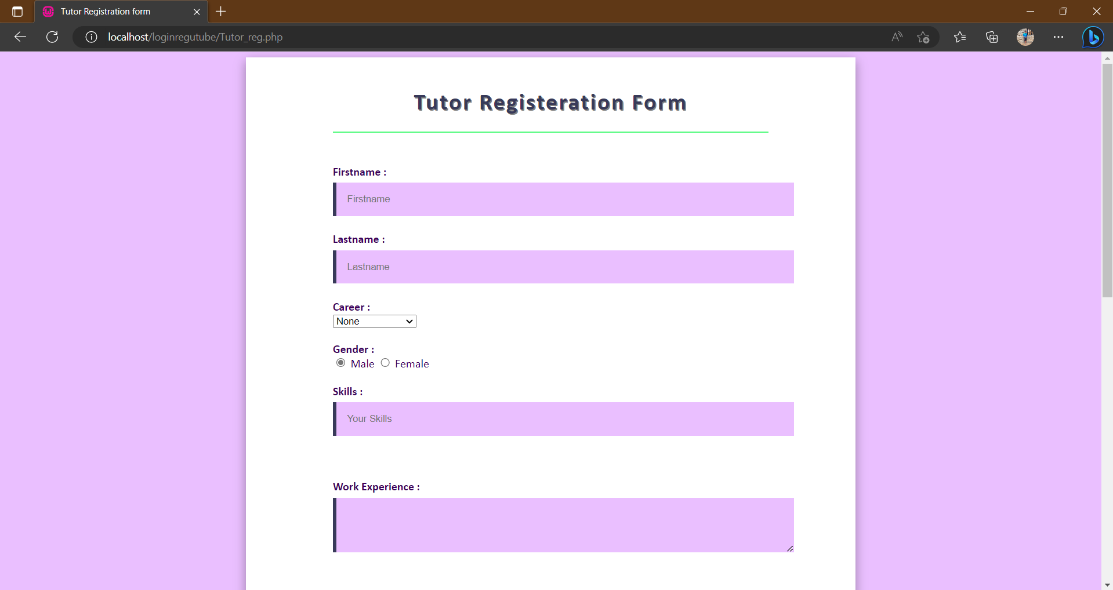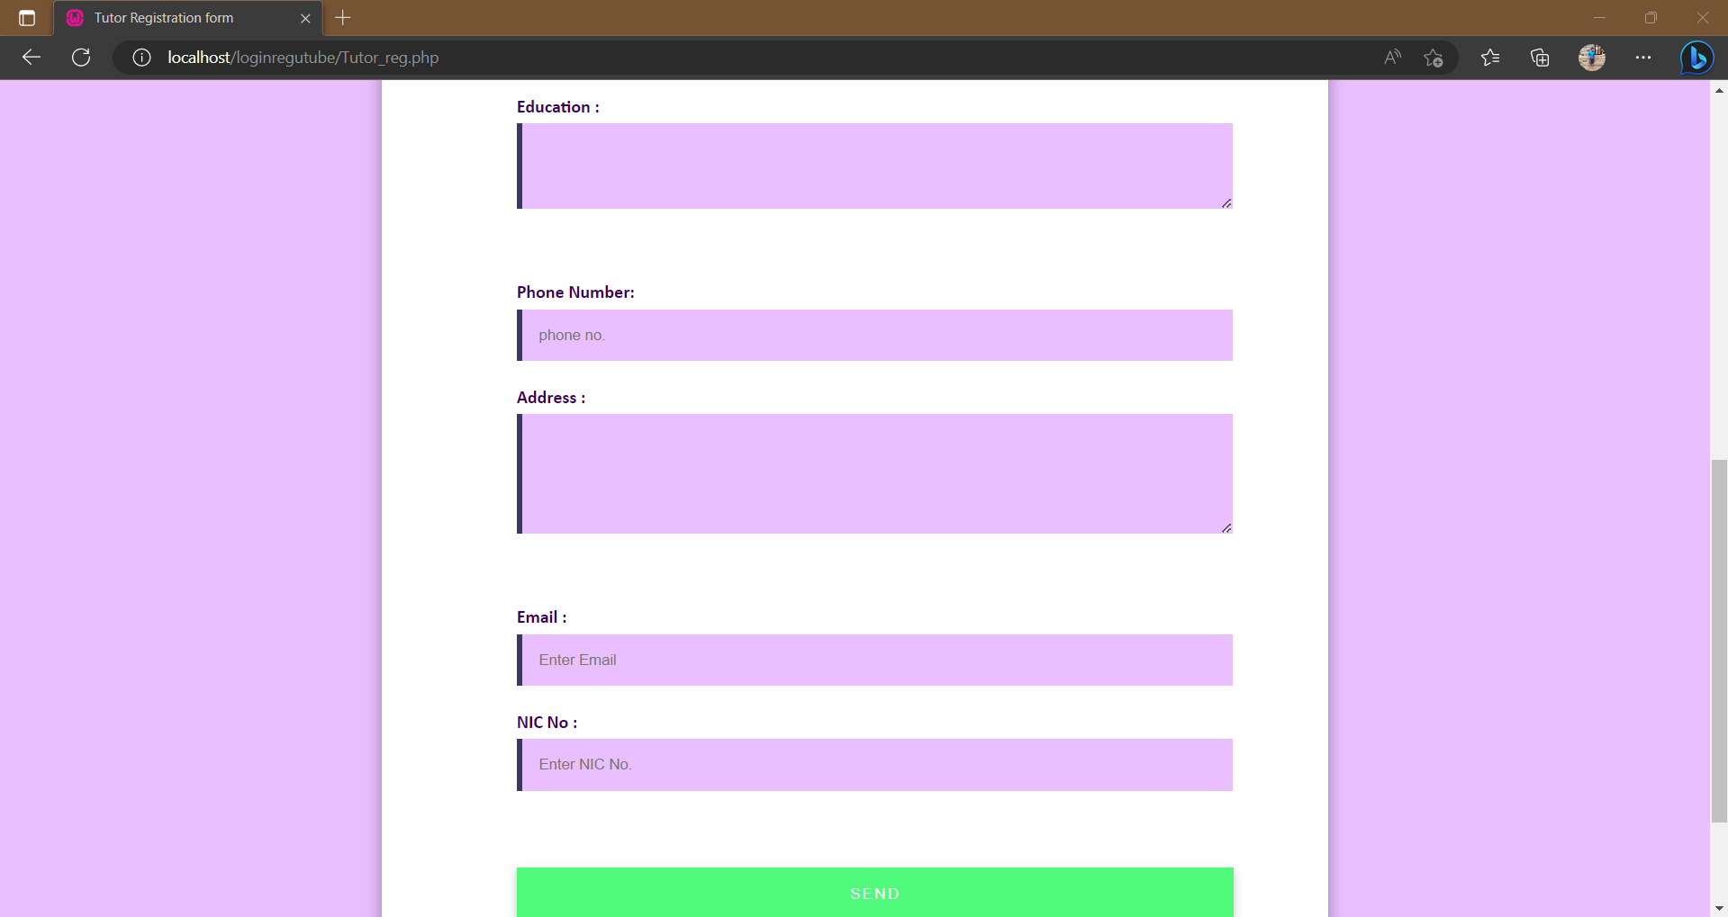

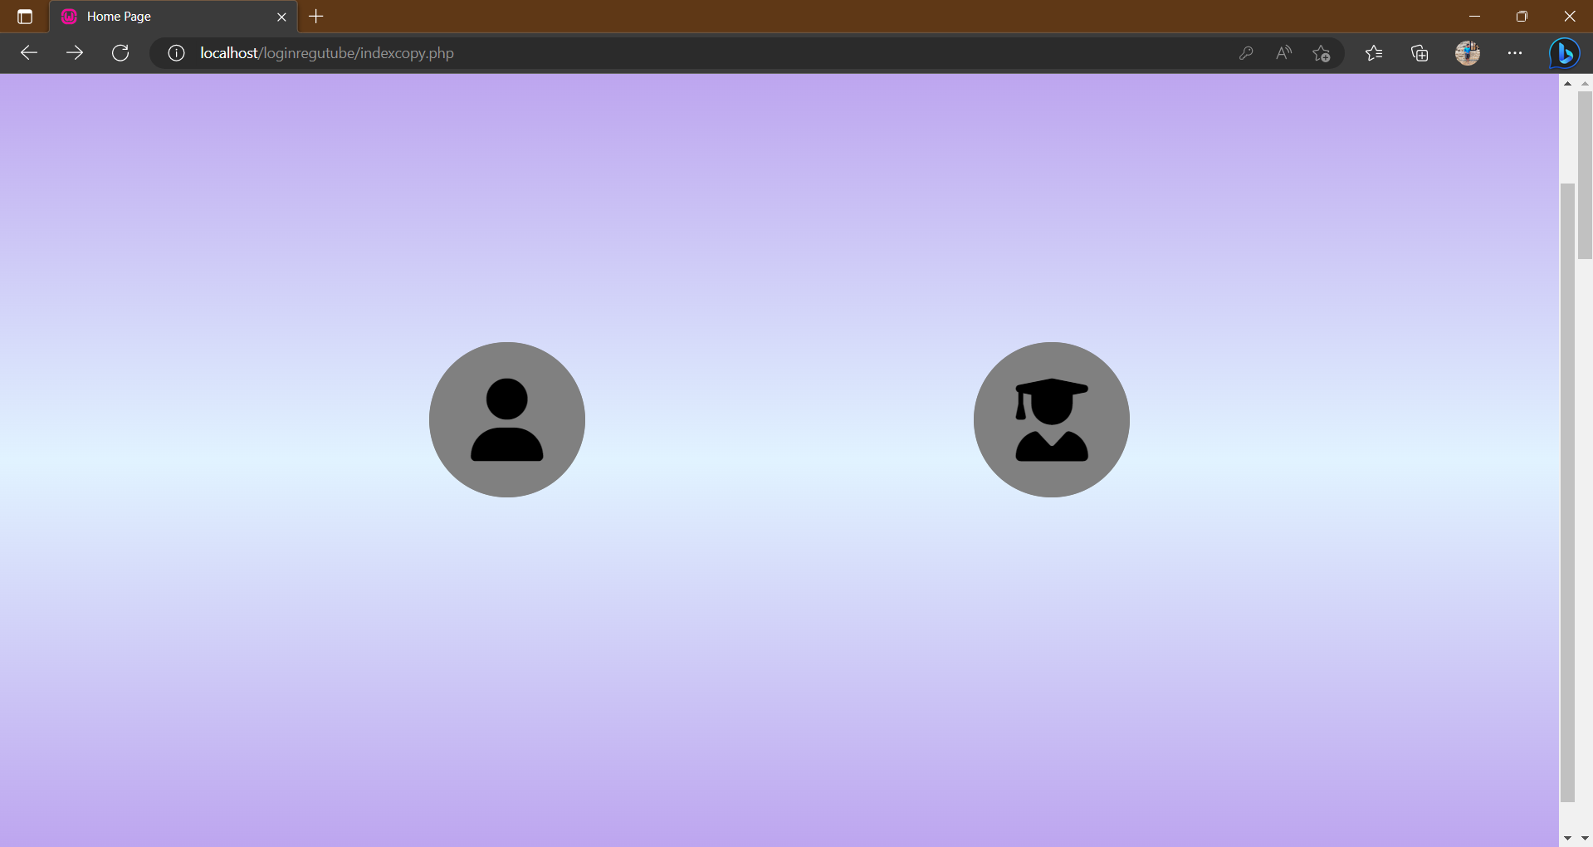

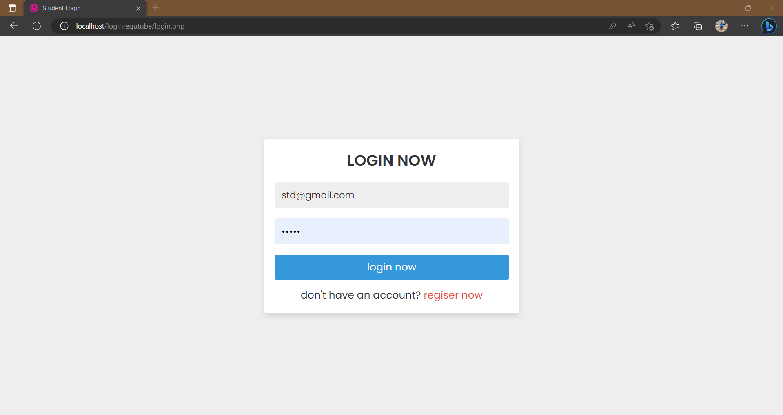

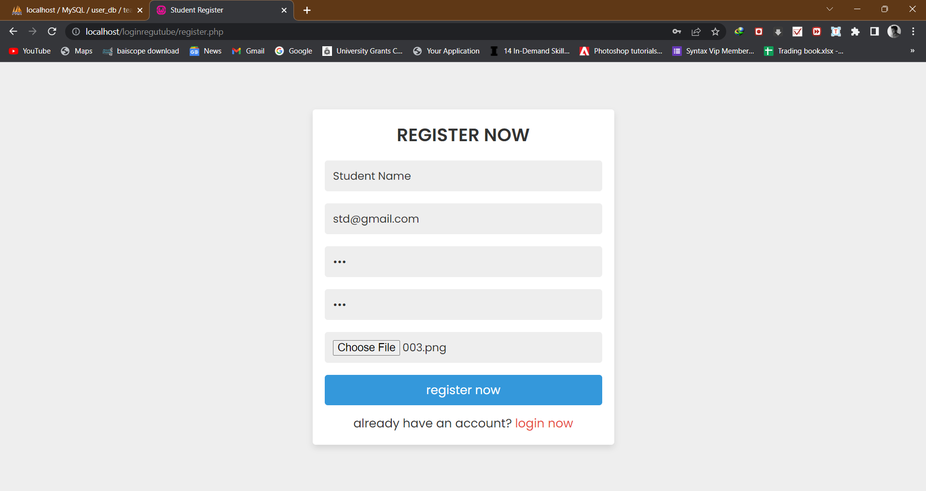

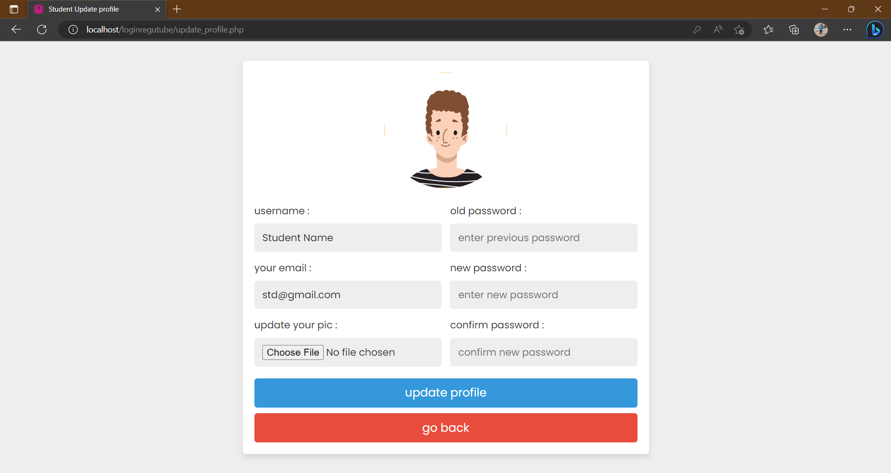

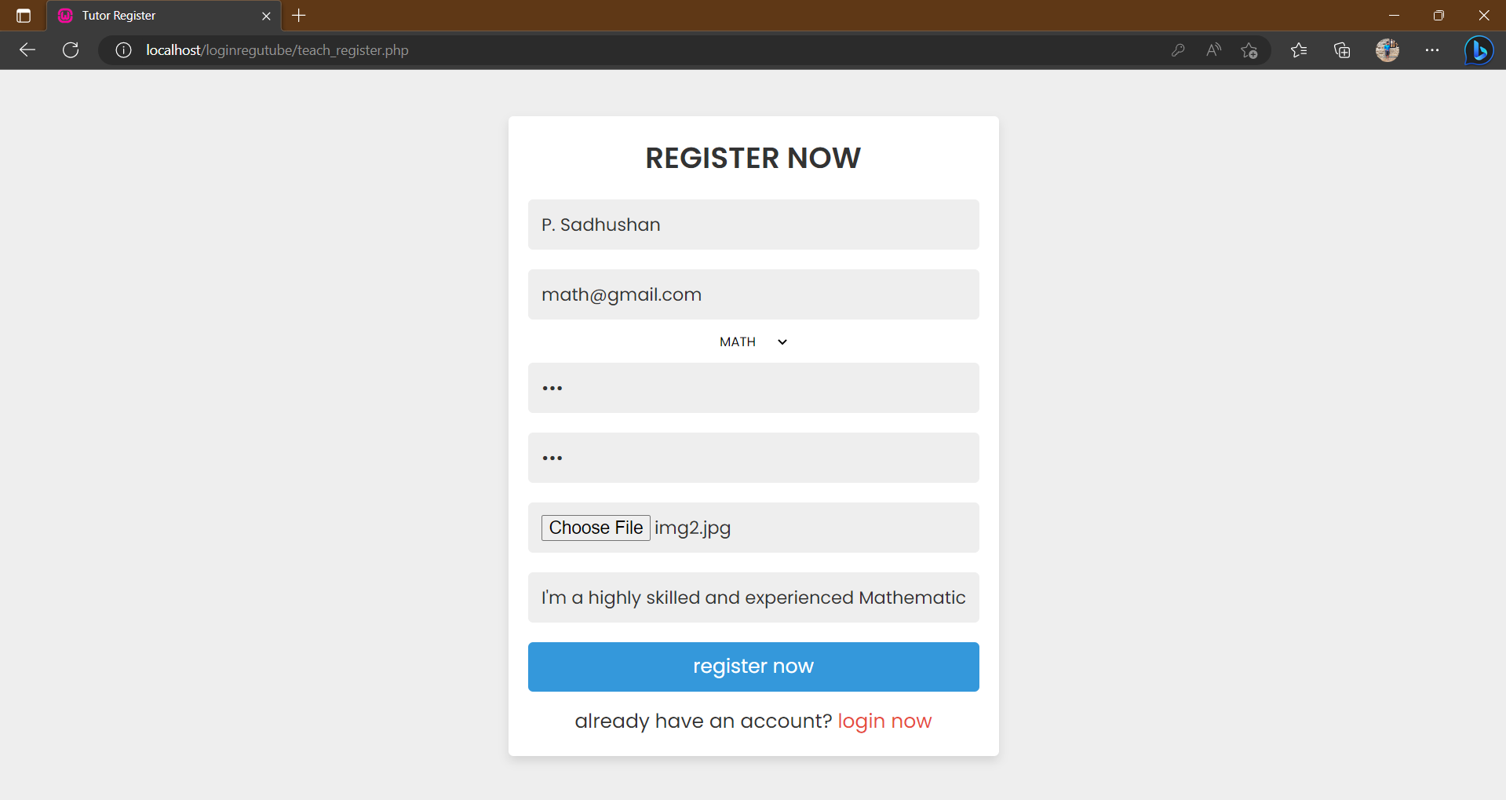

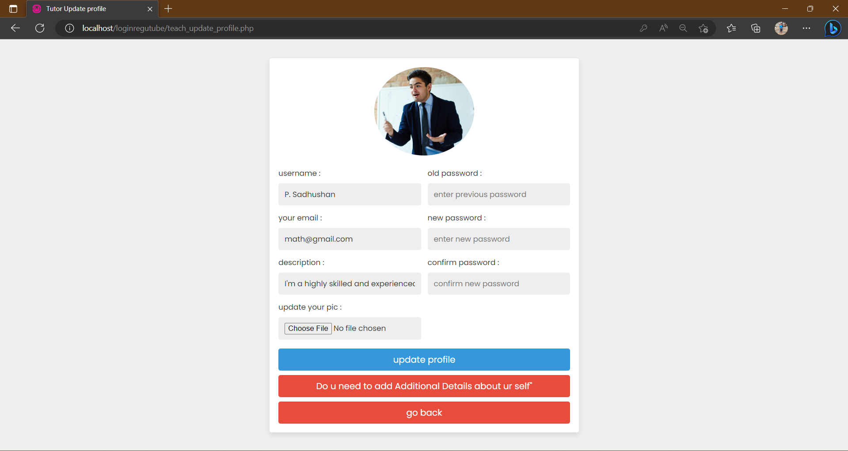

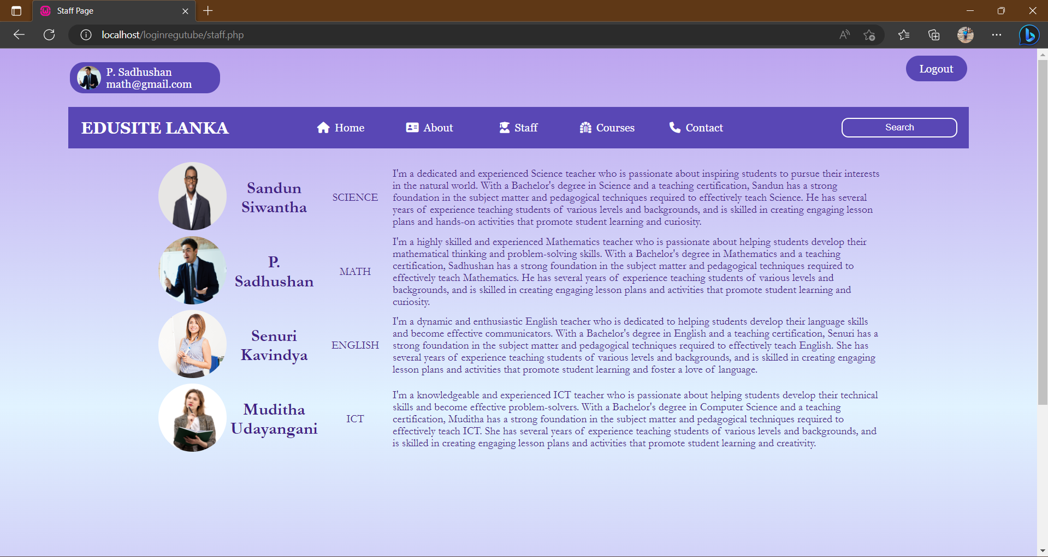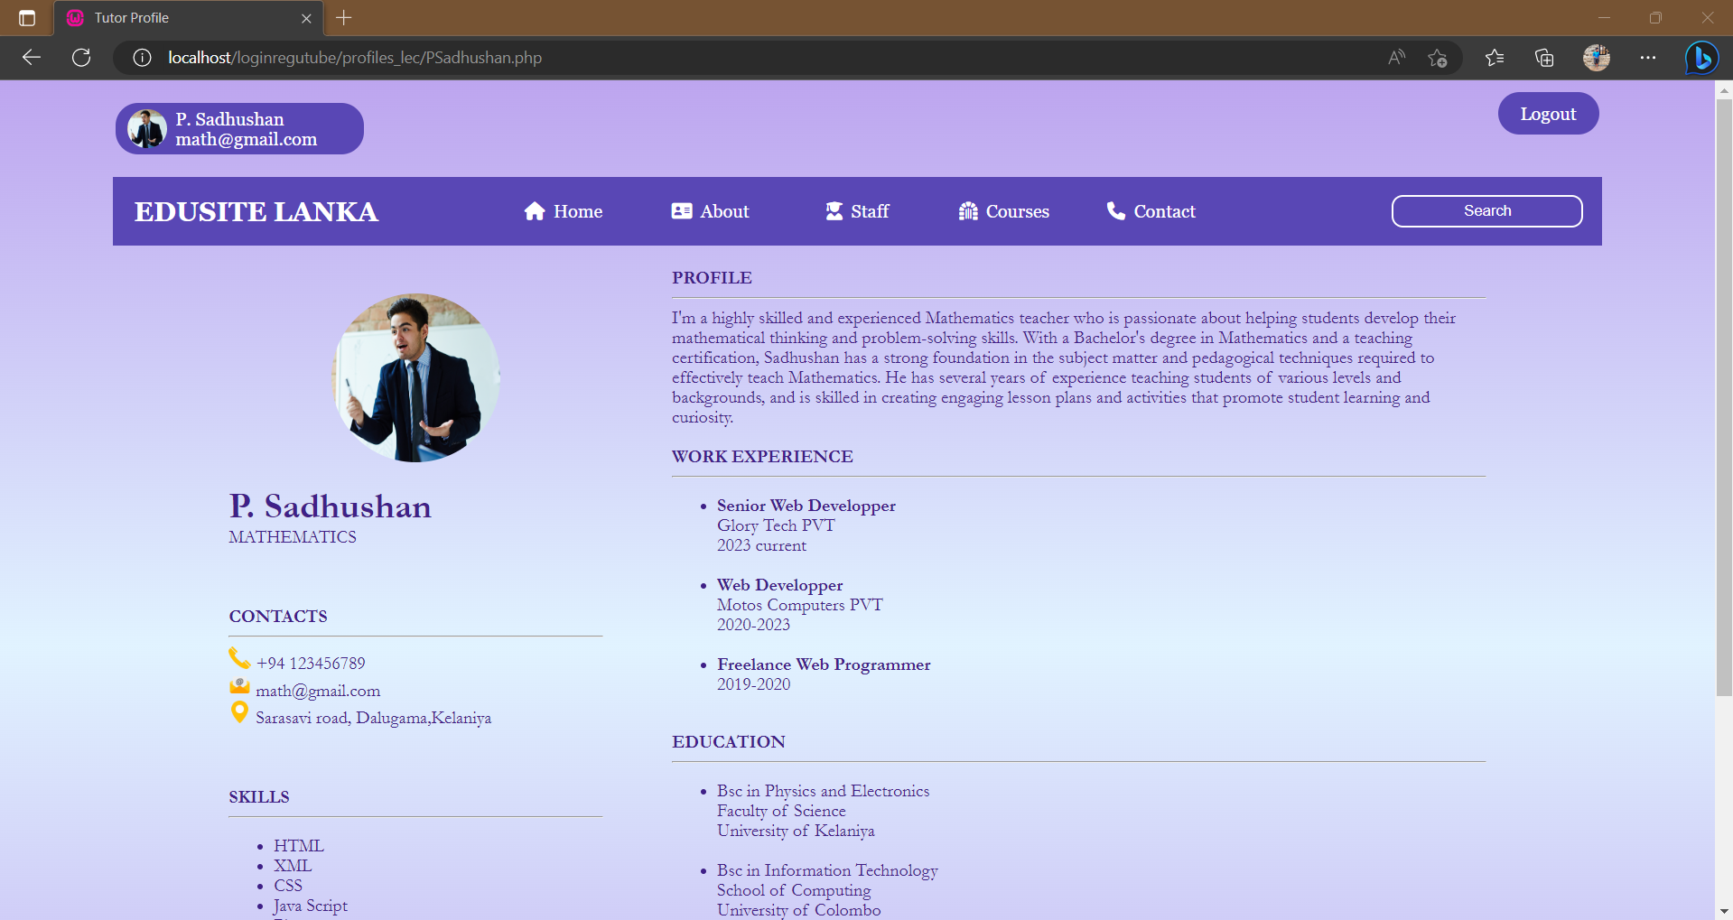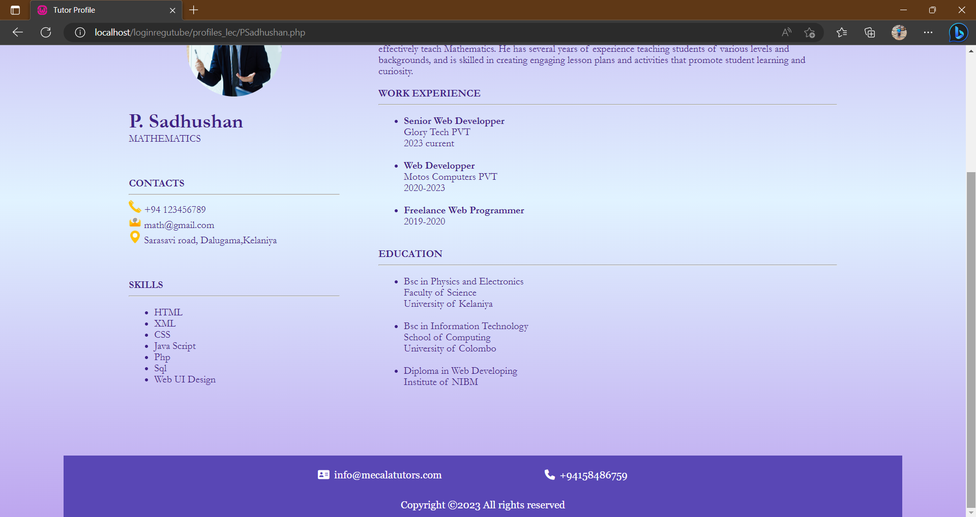

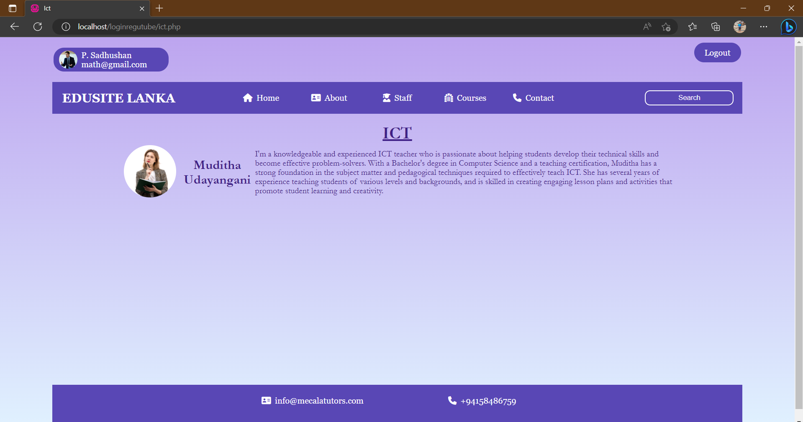

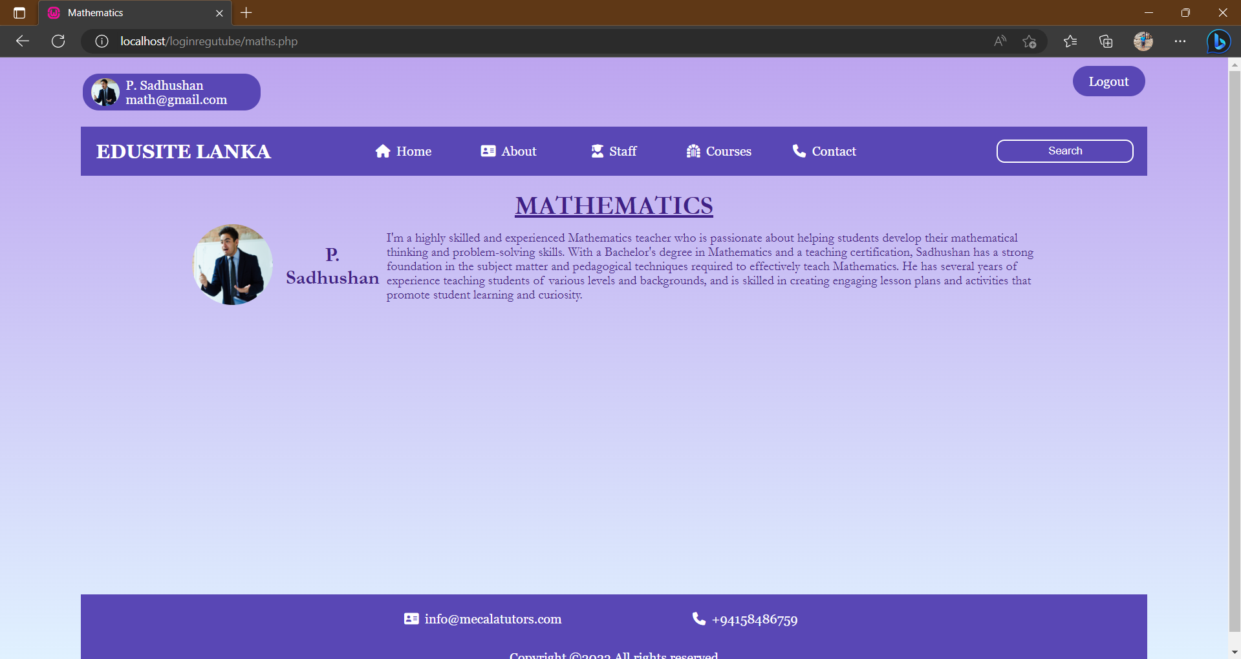

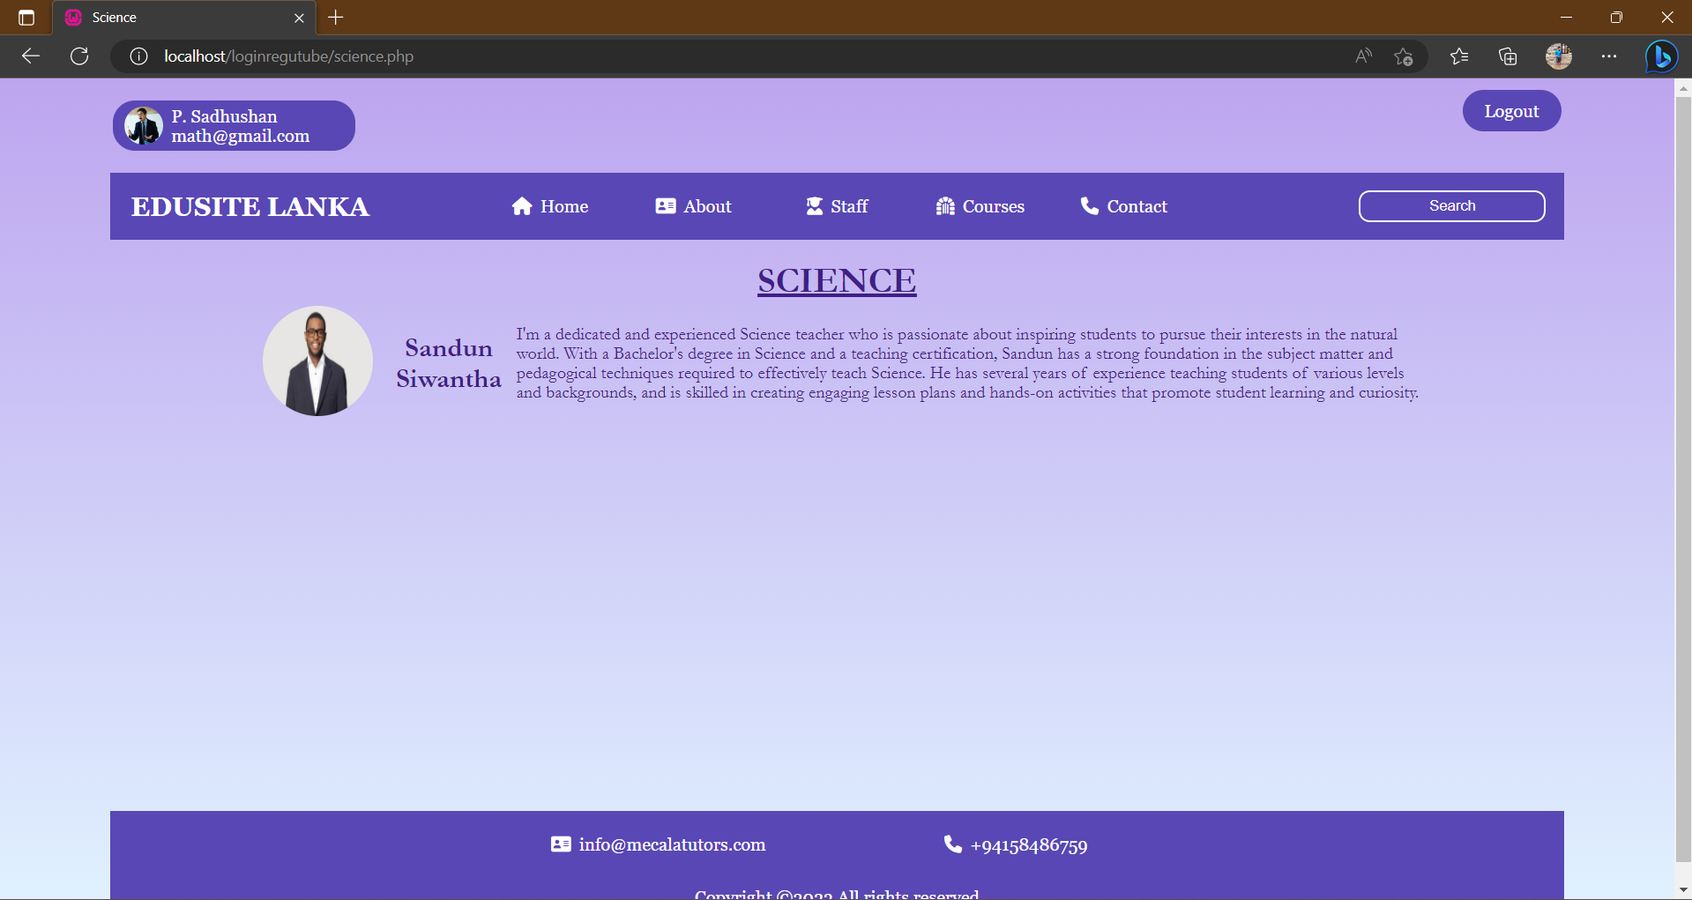

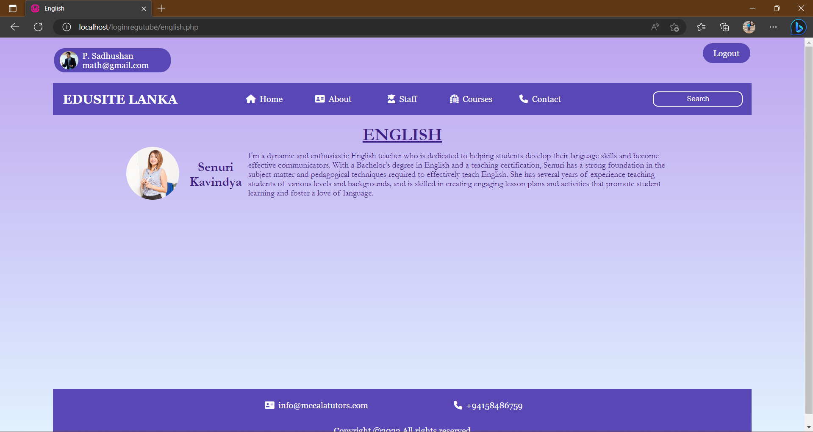

**IMPLEMENTATION**

Home Page

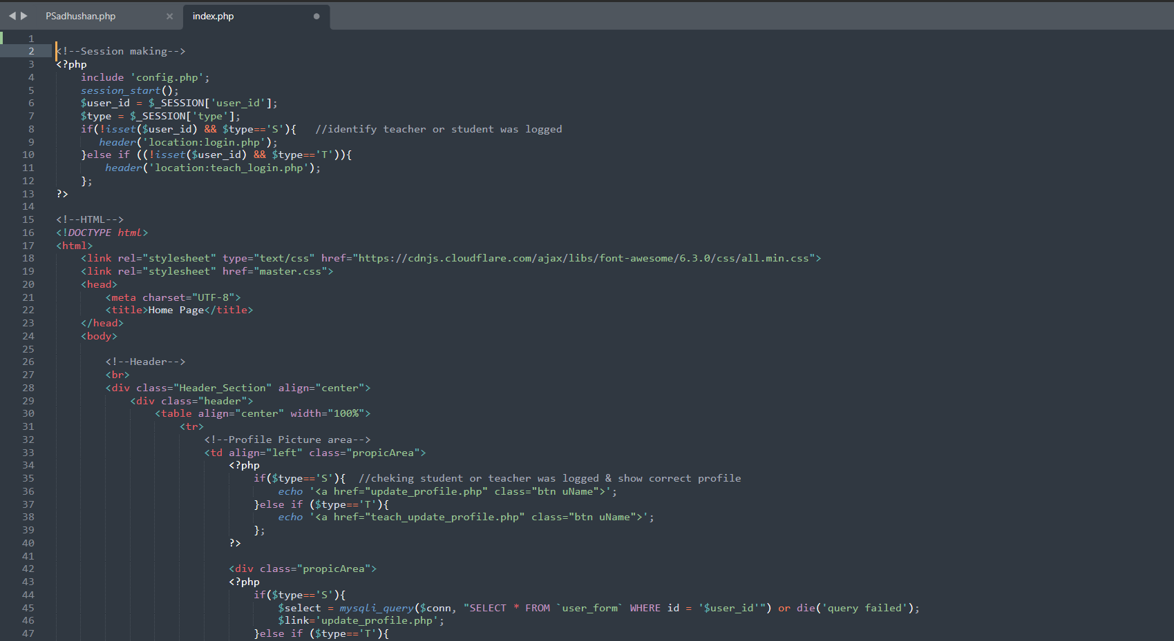

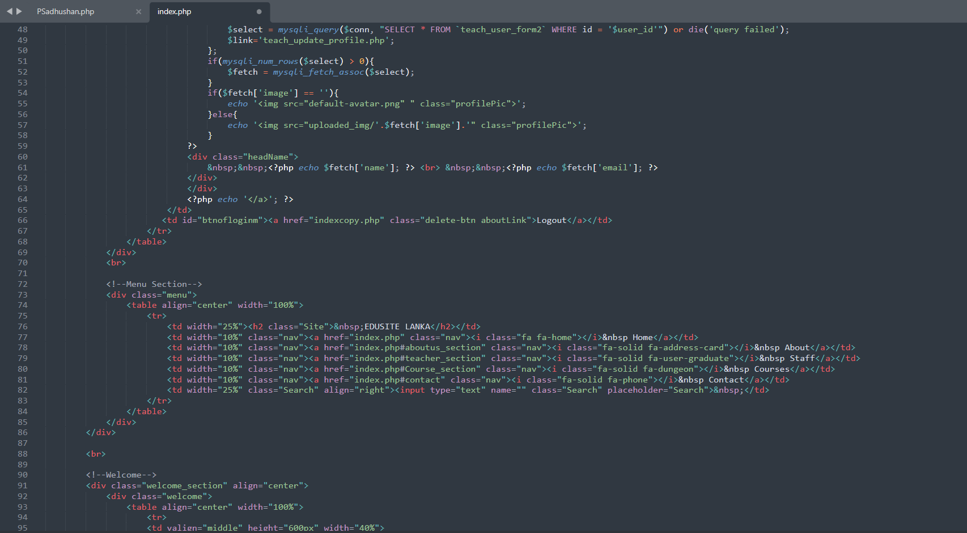

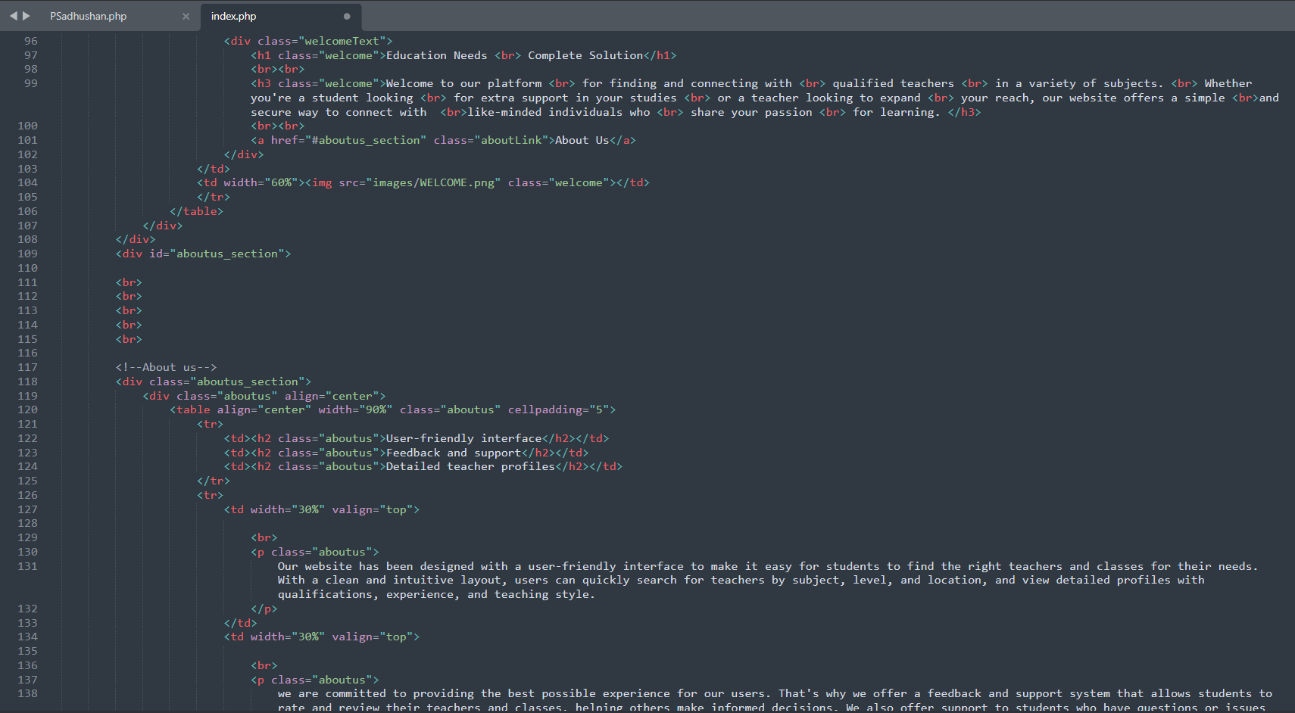

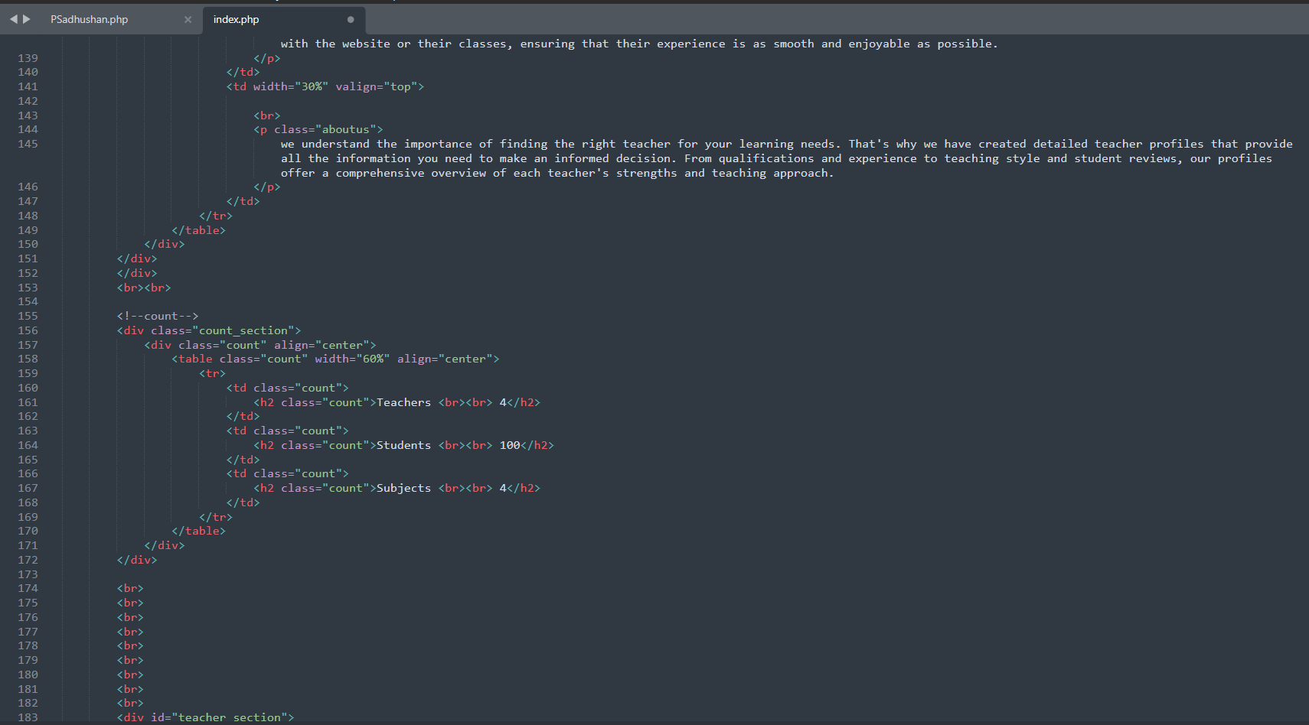

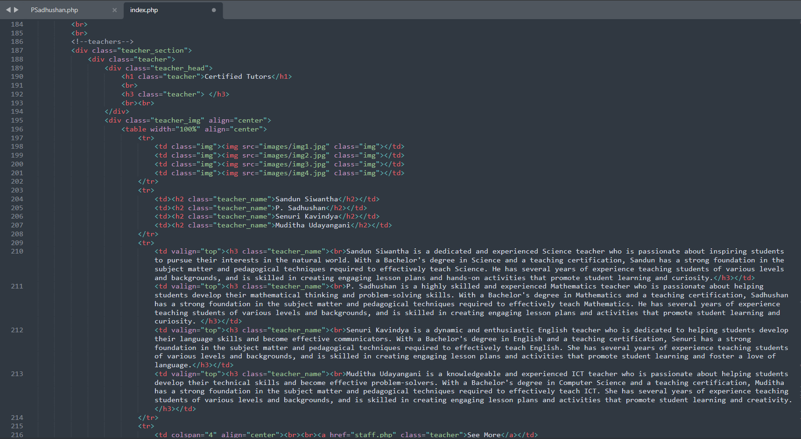

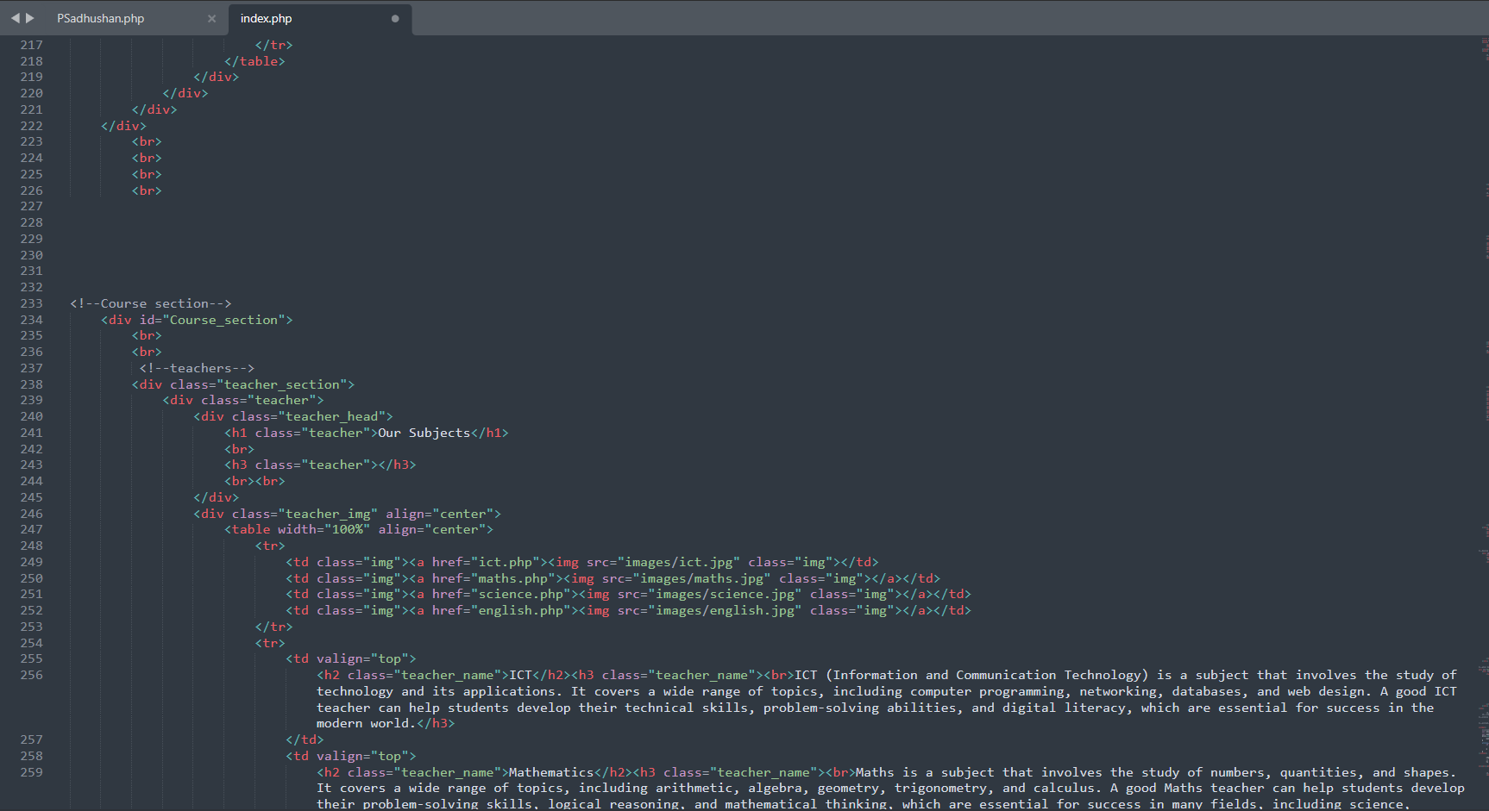

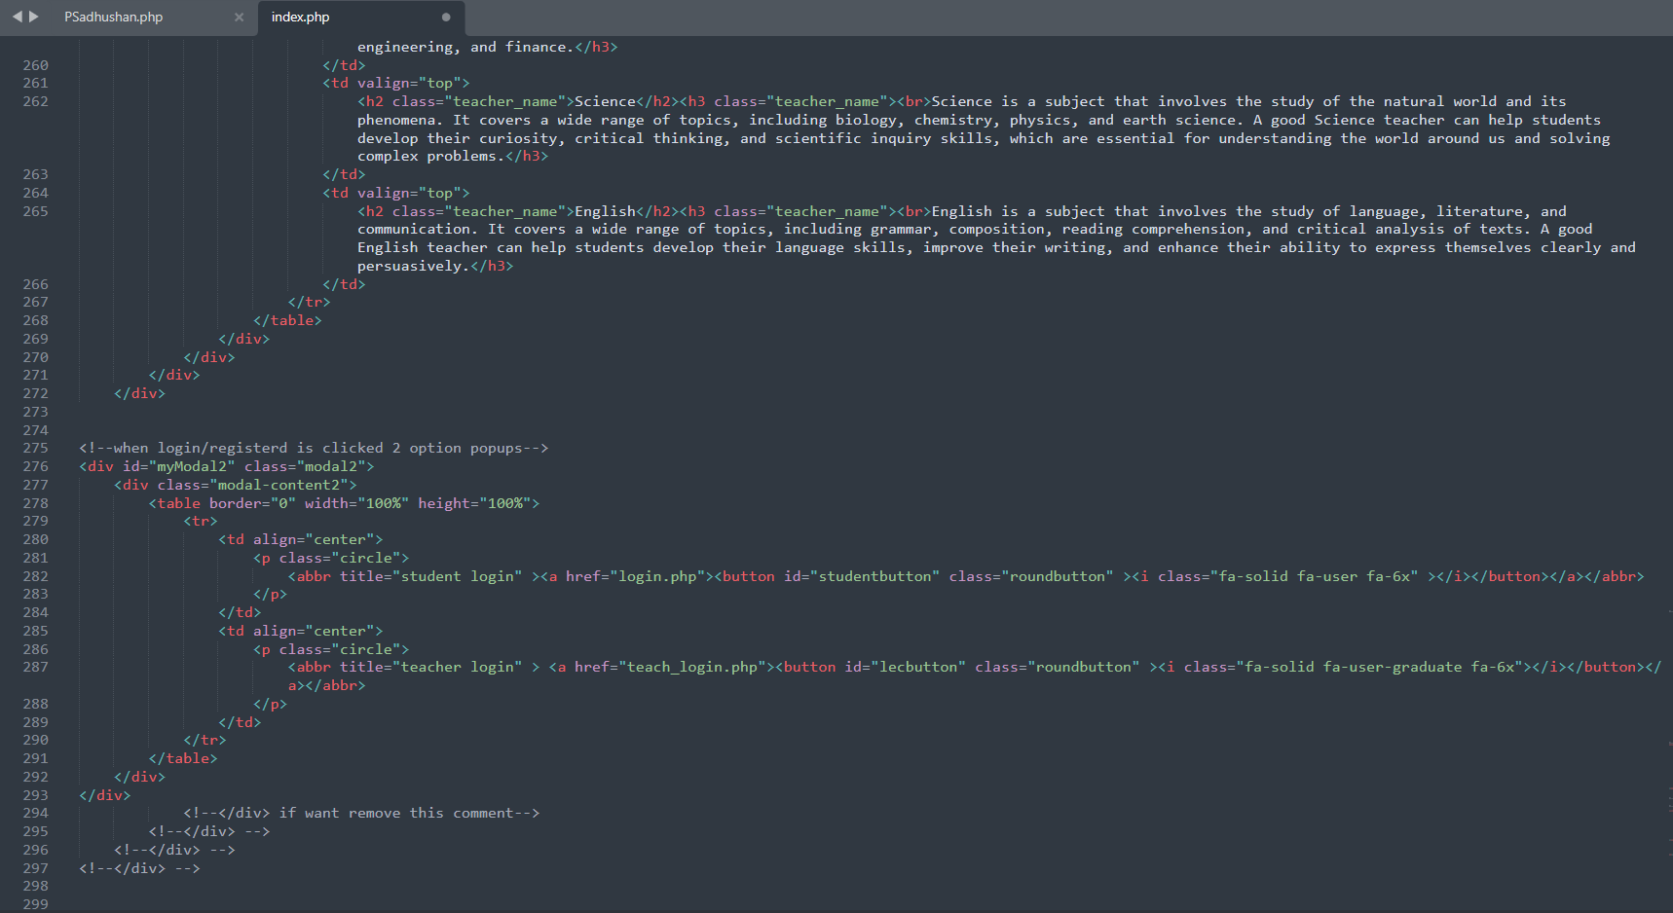

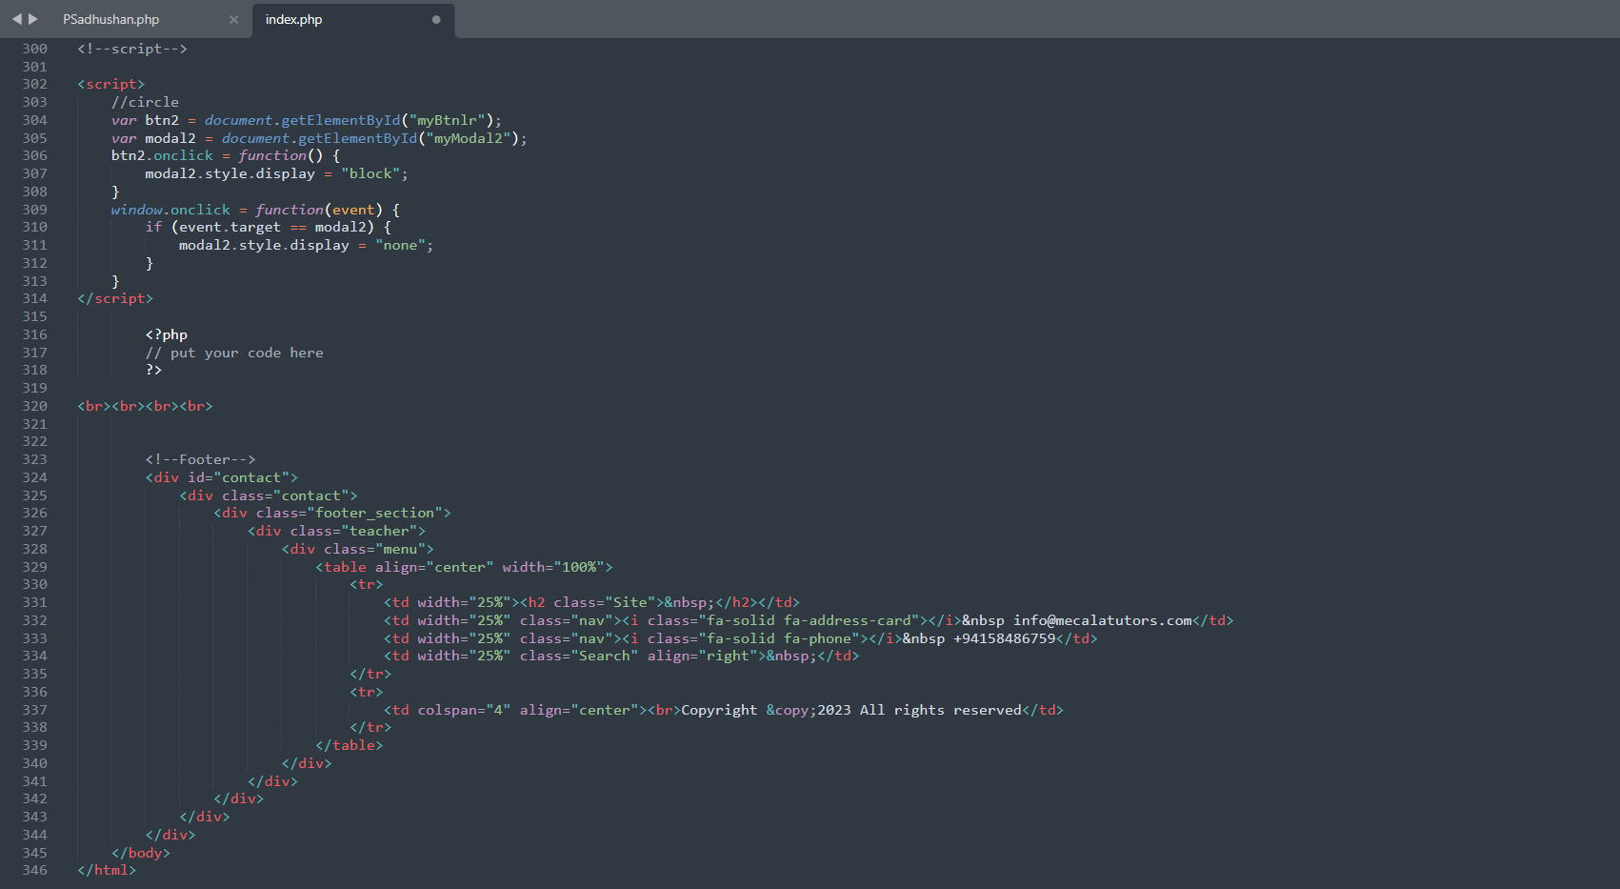

Staff Page

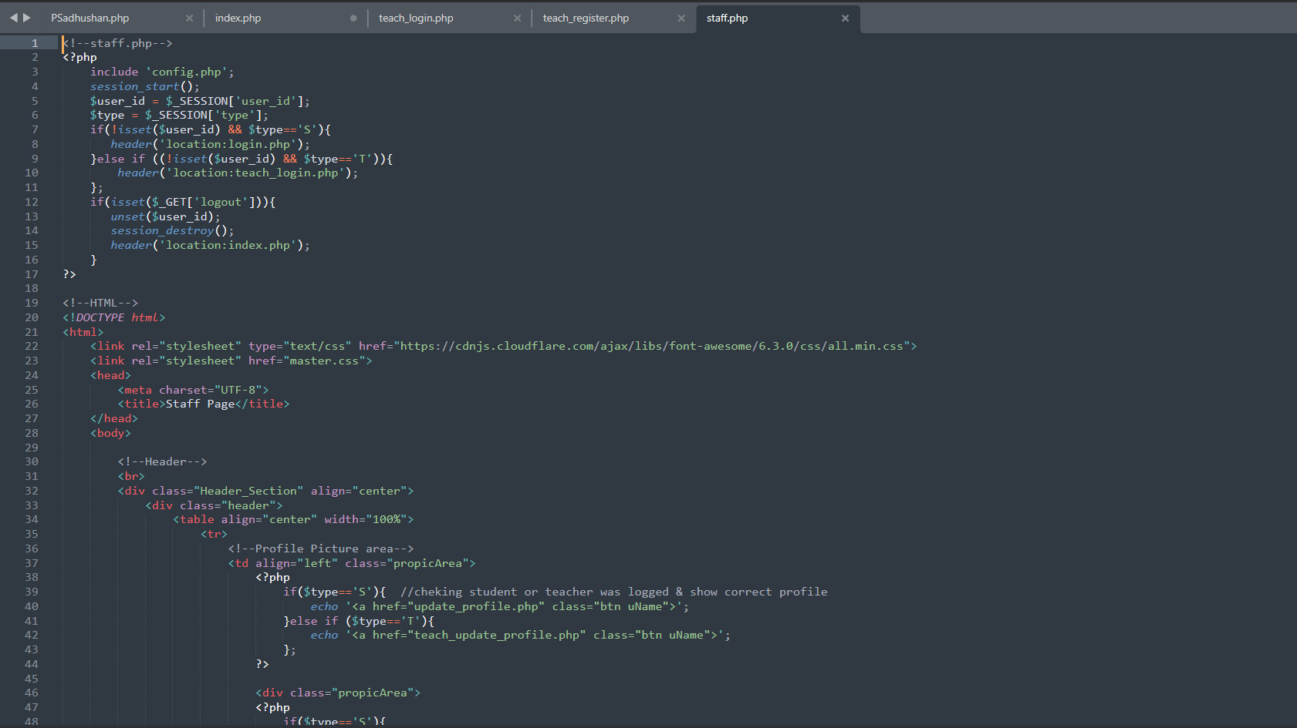

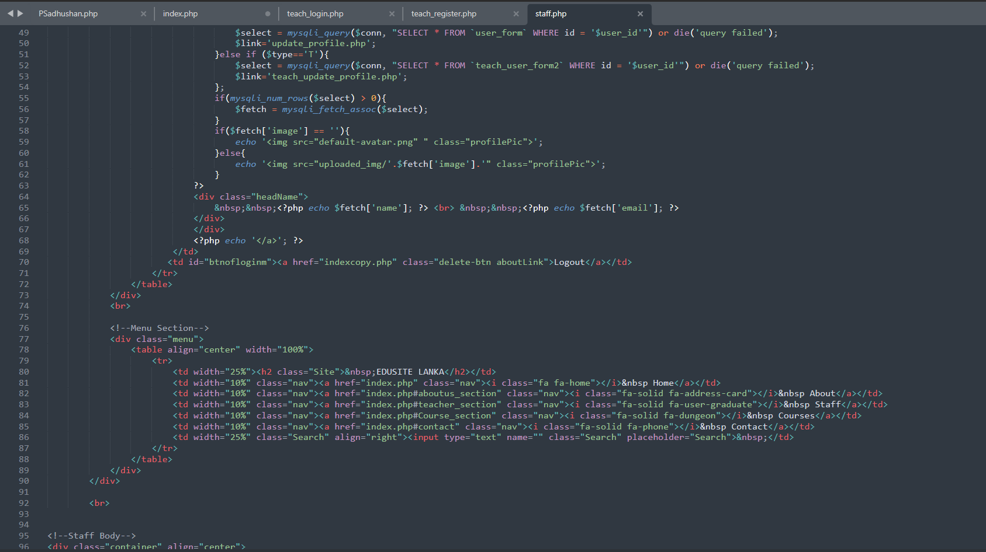

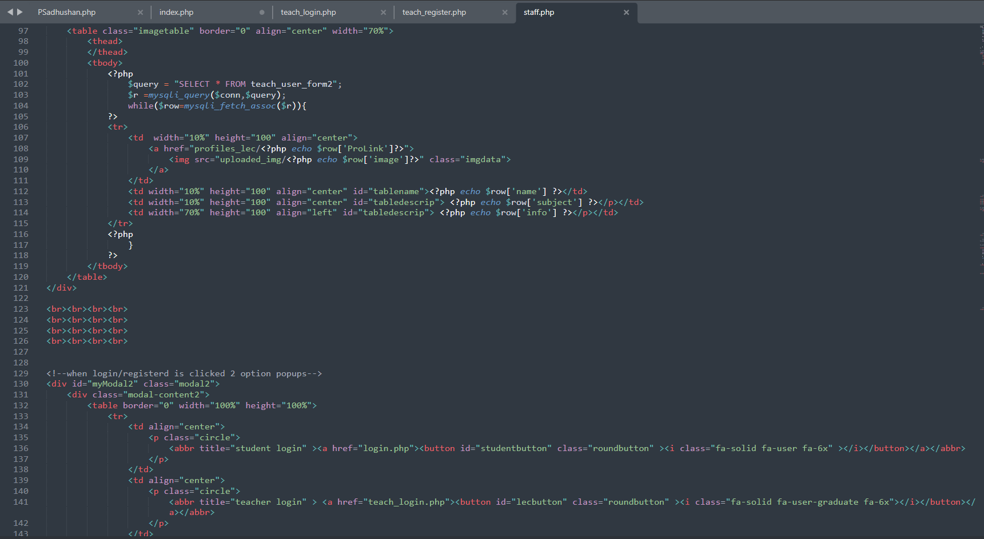

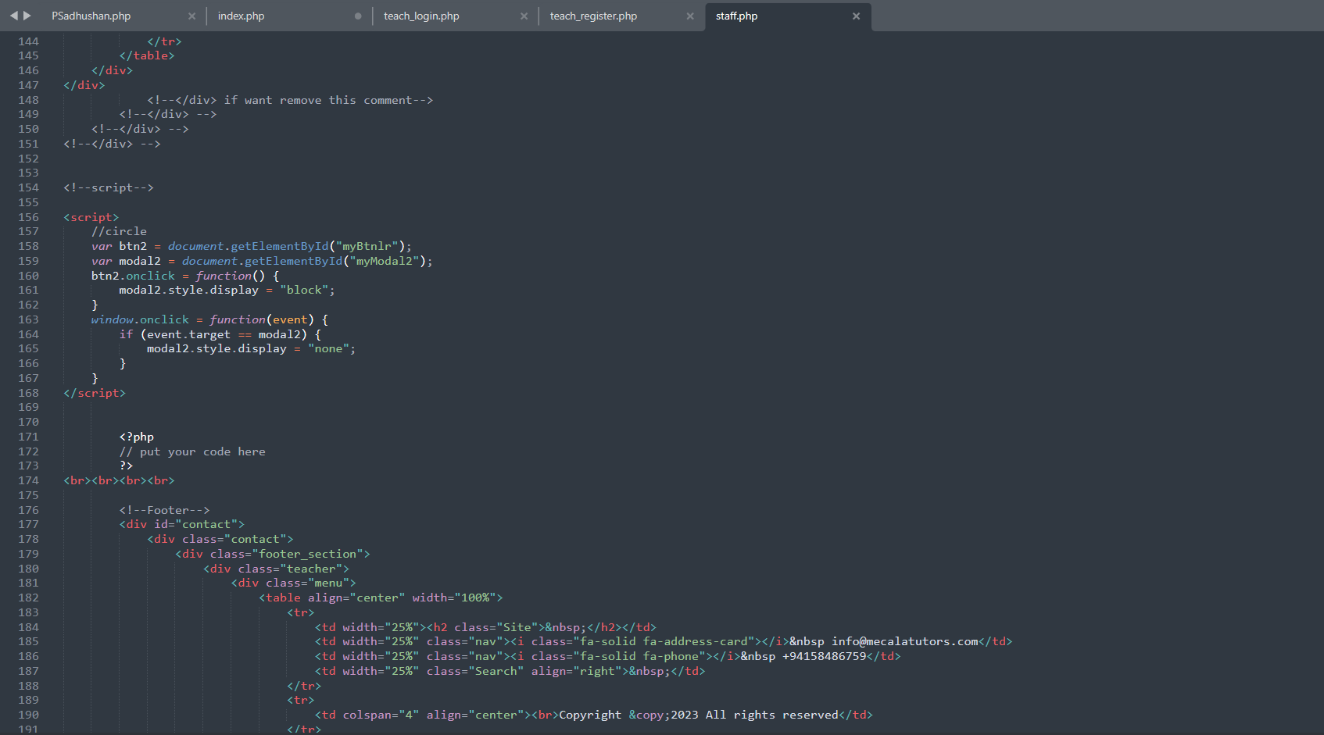

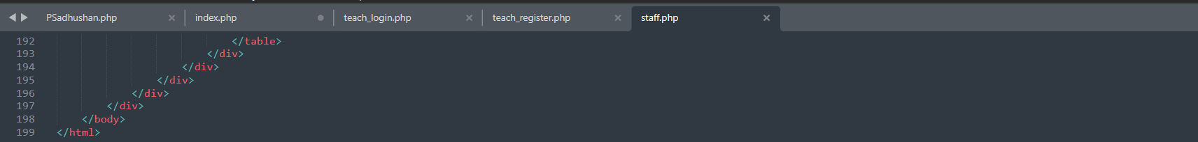

Tutor login page

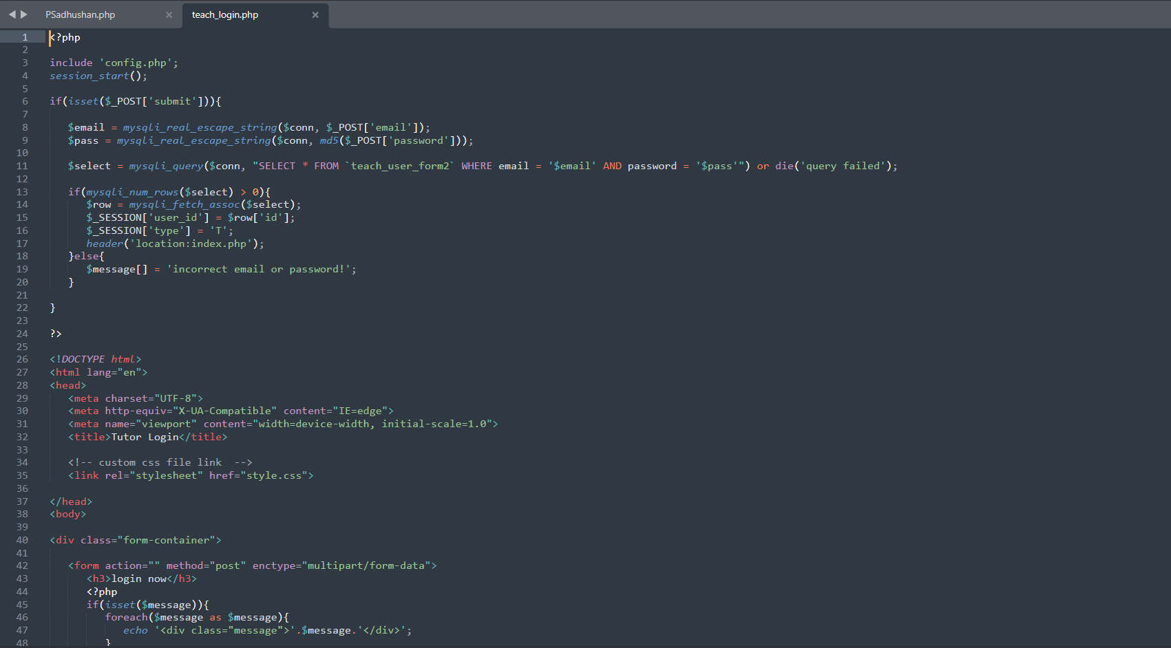

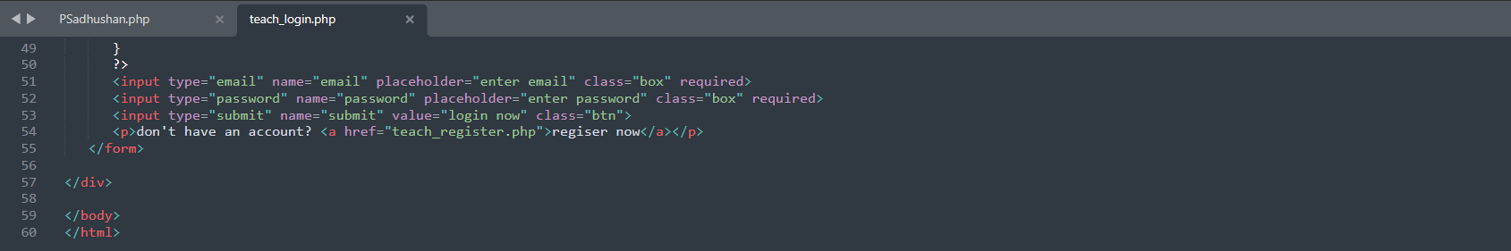

Student Login page

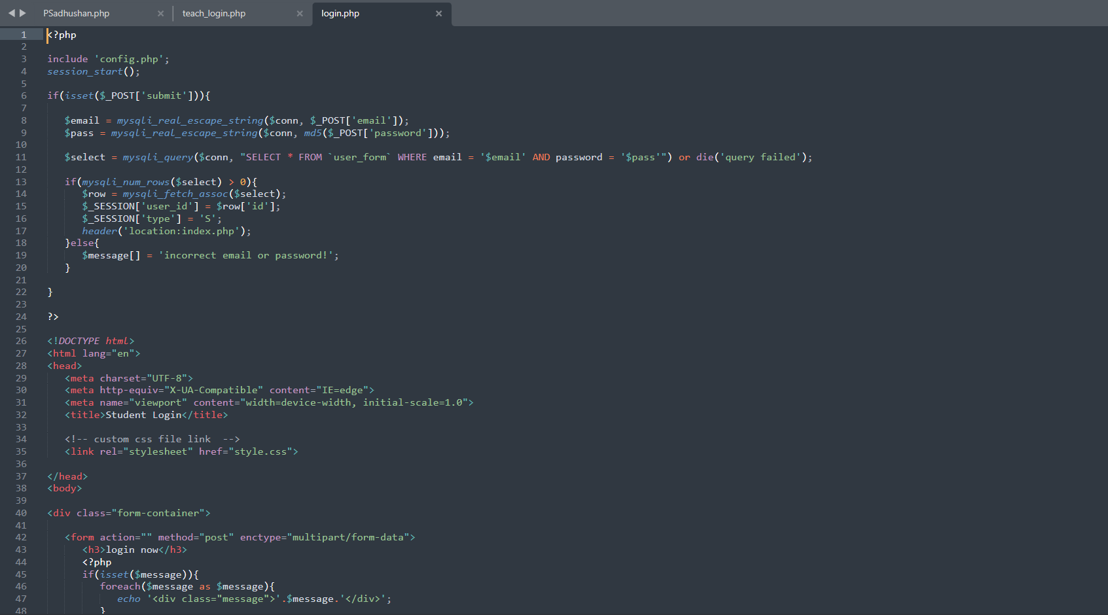

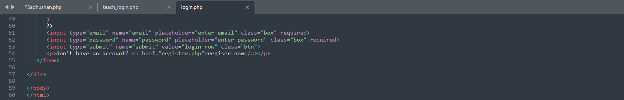

Tutor Register Page

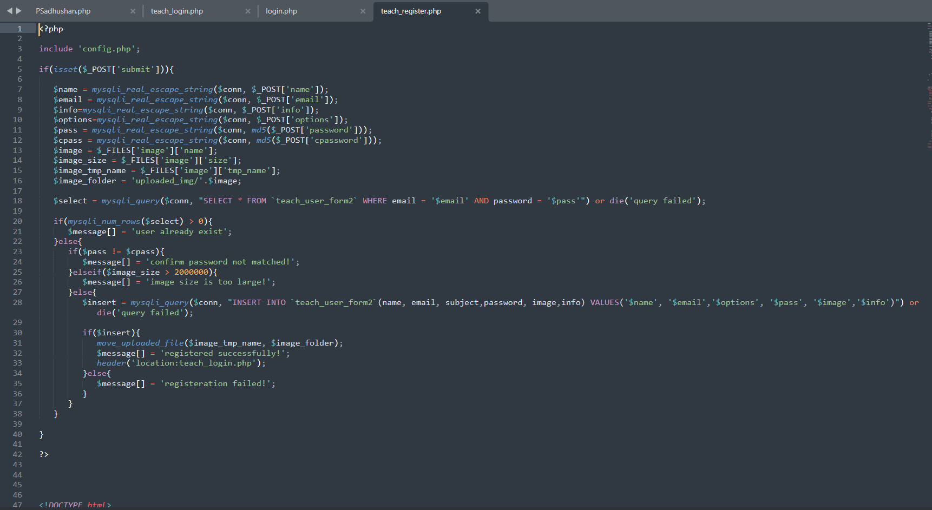

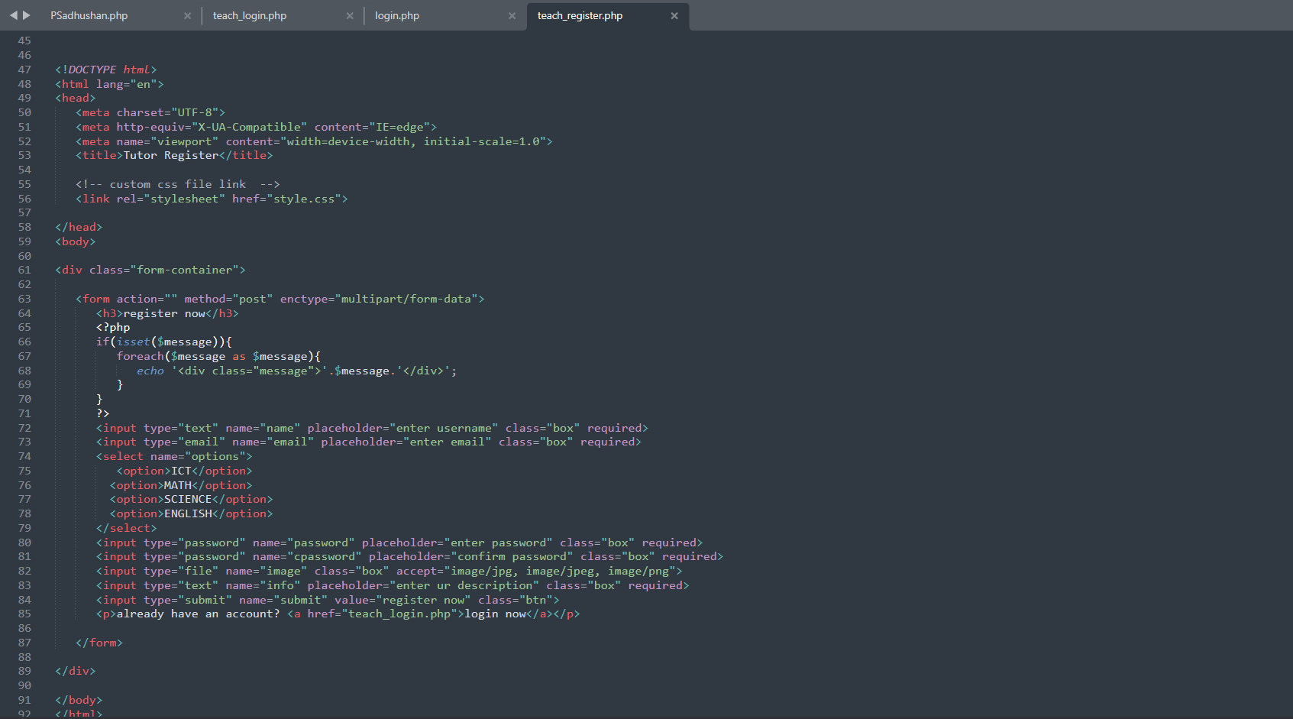

Student Register Page

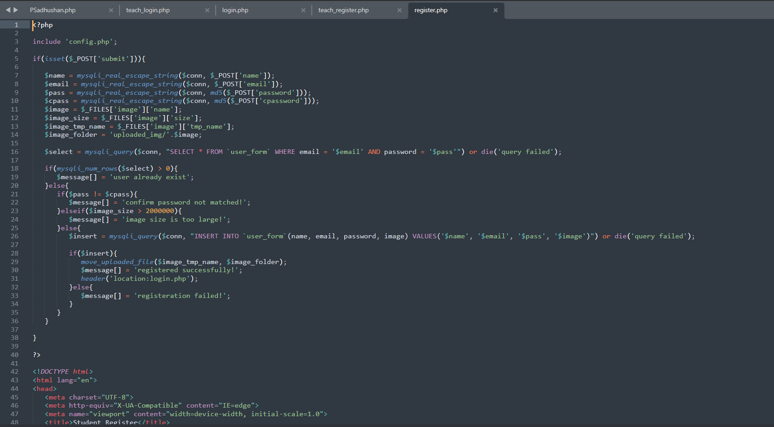

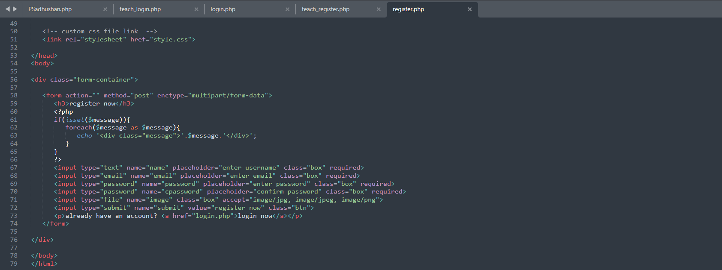

Mathematic Page

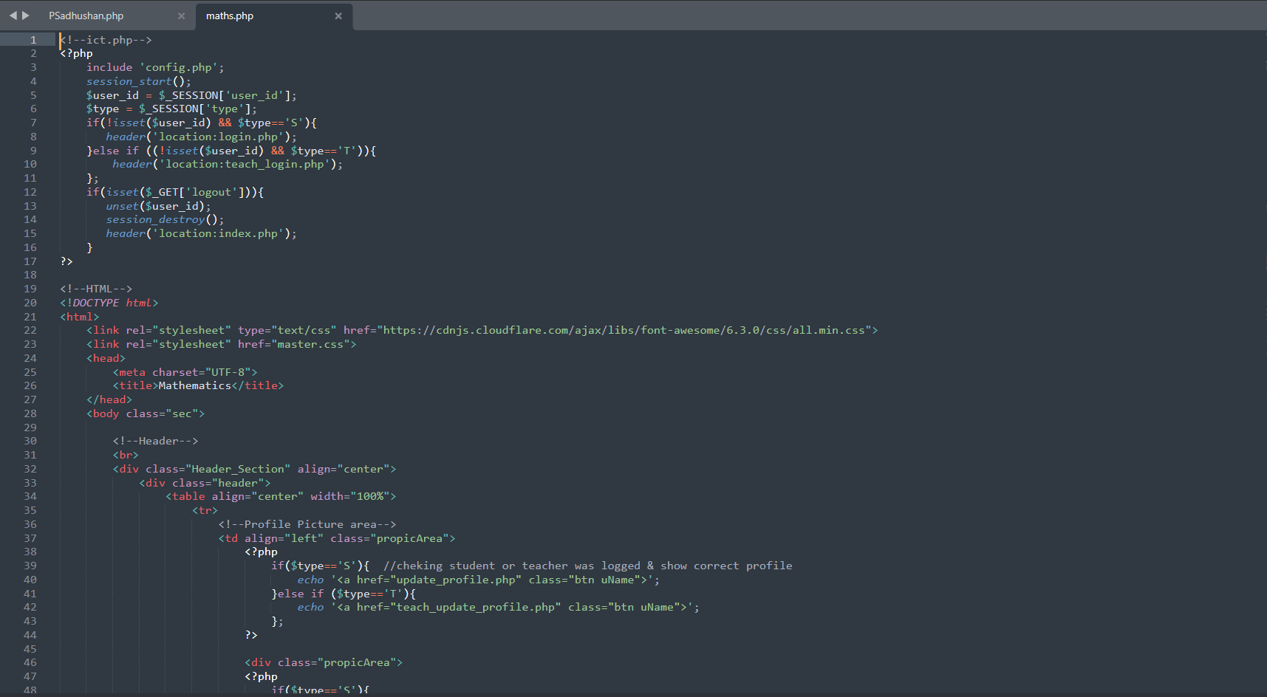

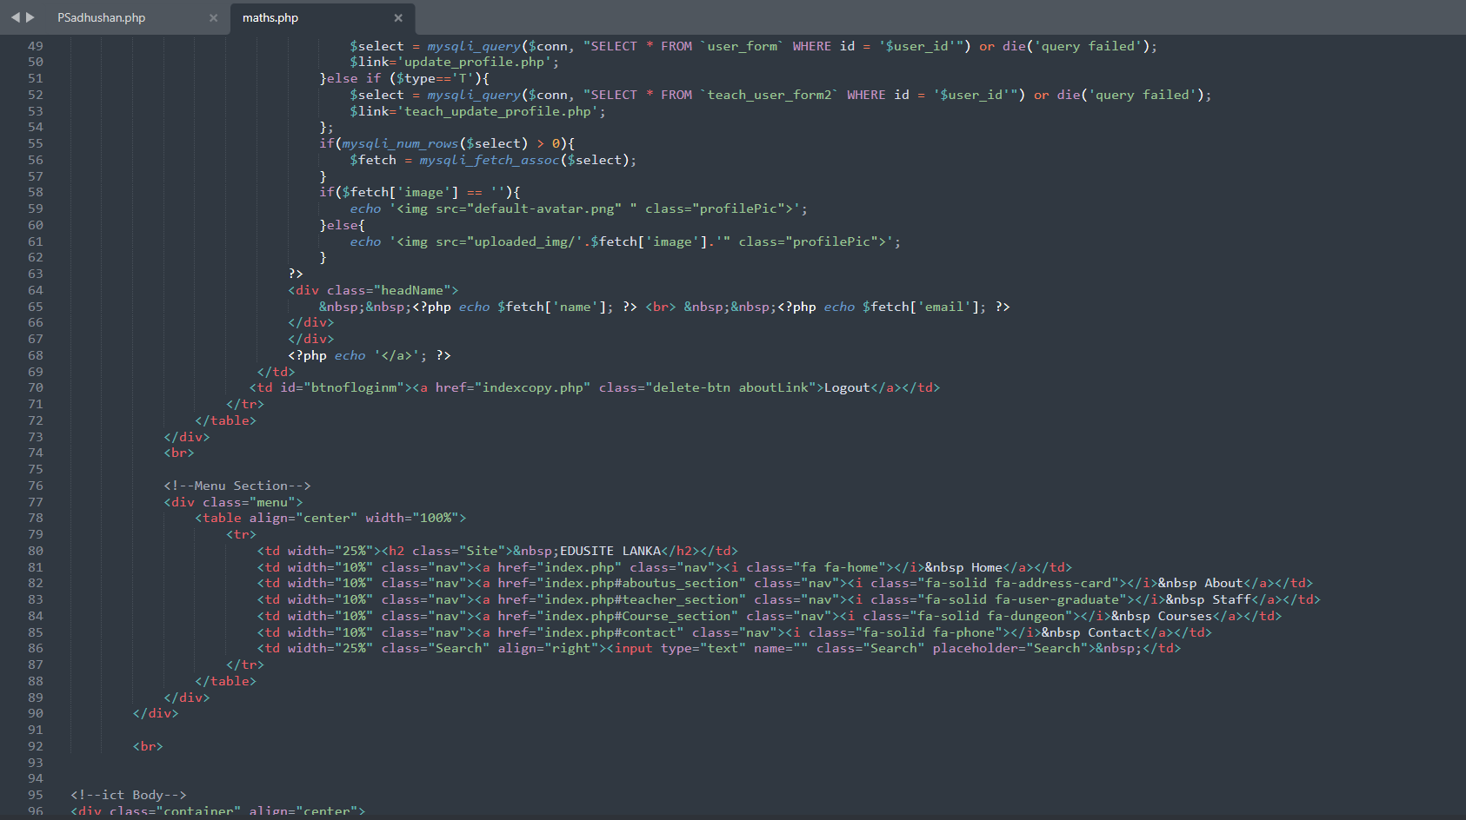

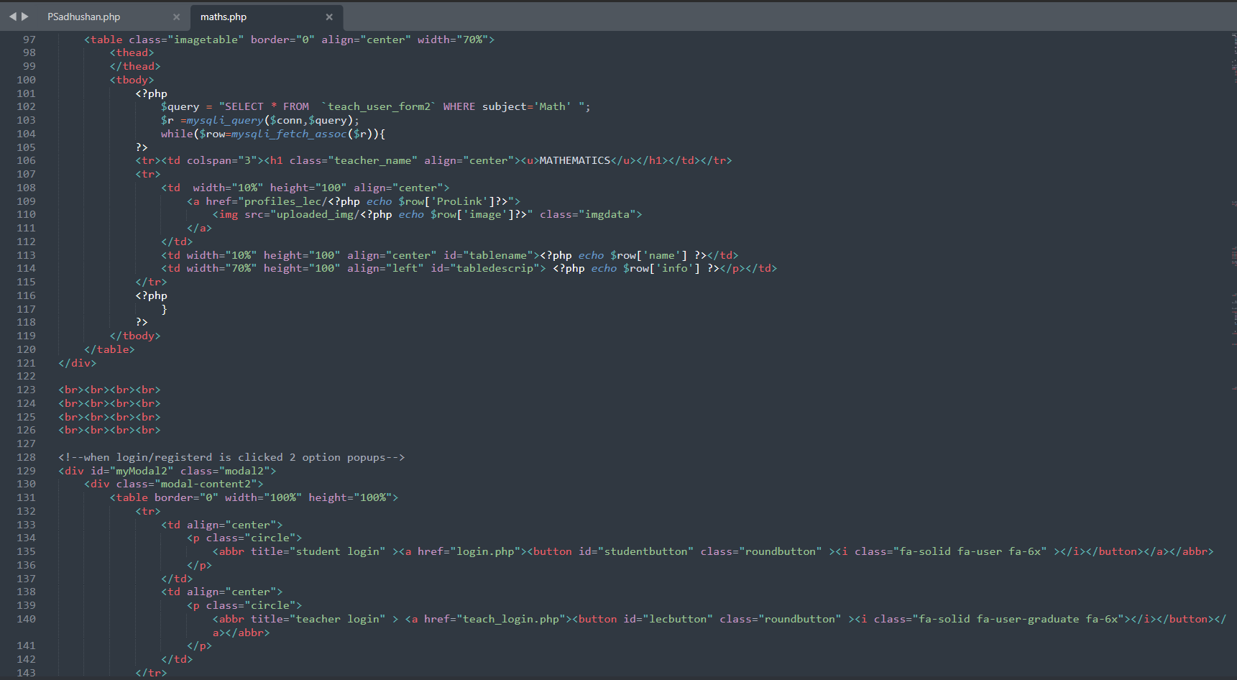

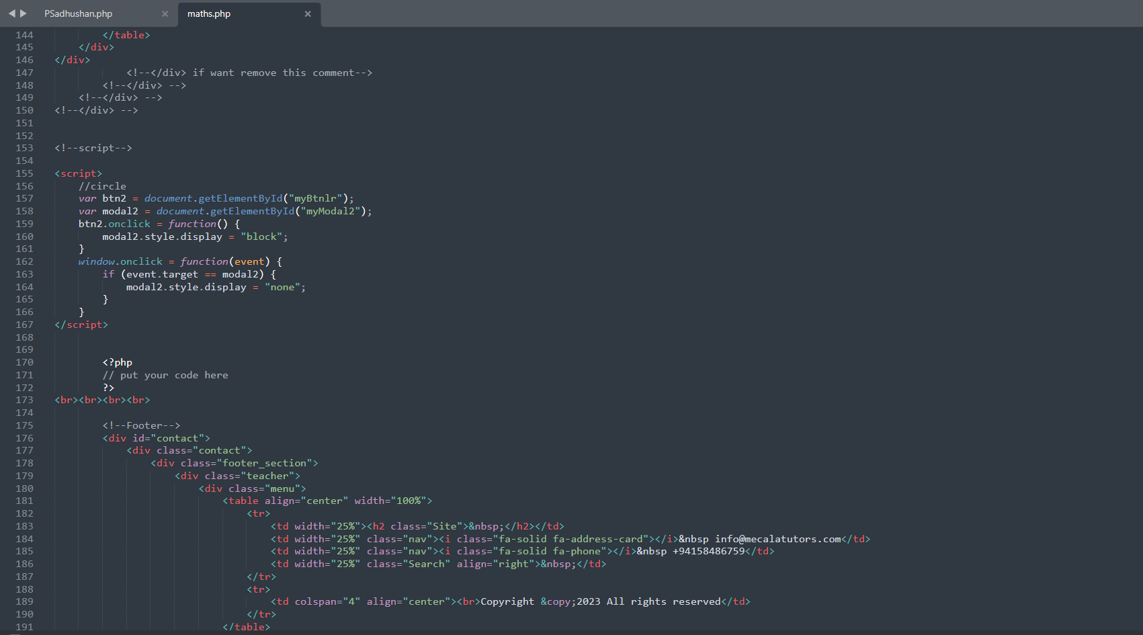

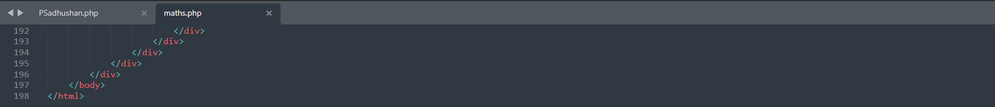

Science Page

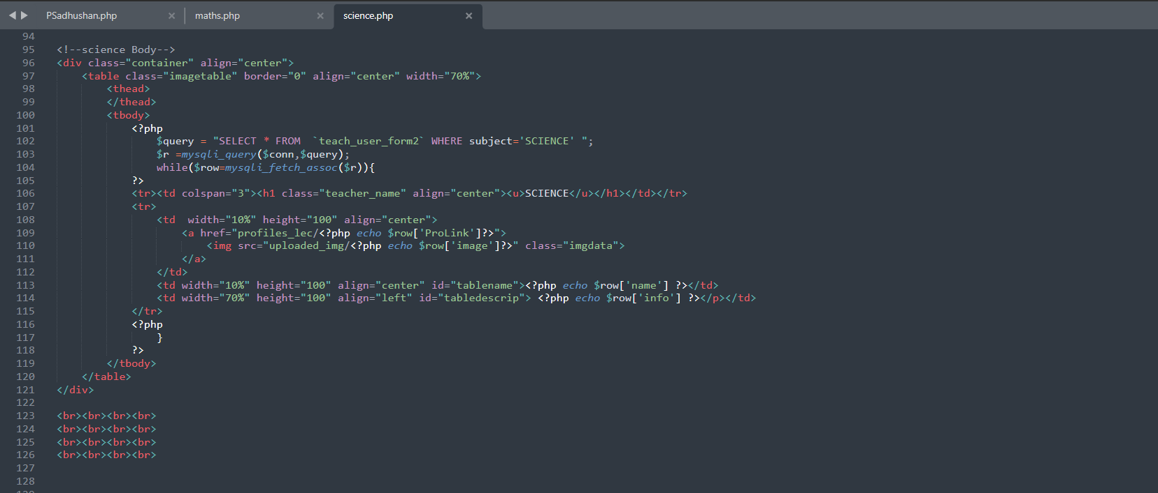

ICT page

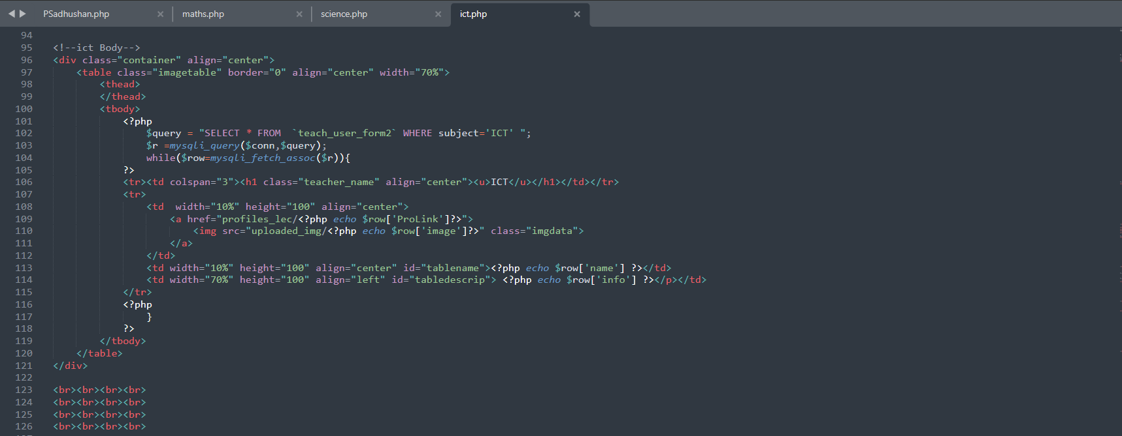

English Page

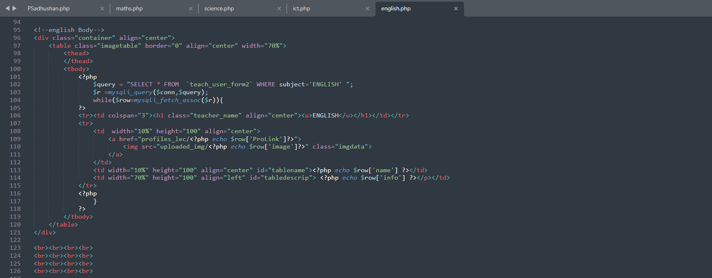

Tutor Profile Page

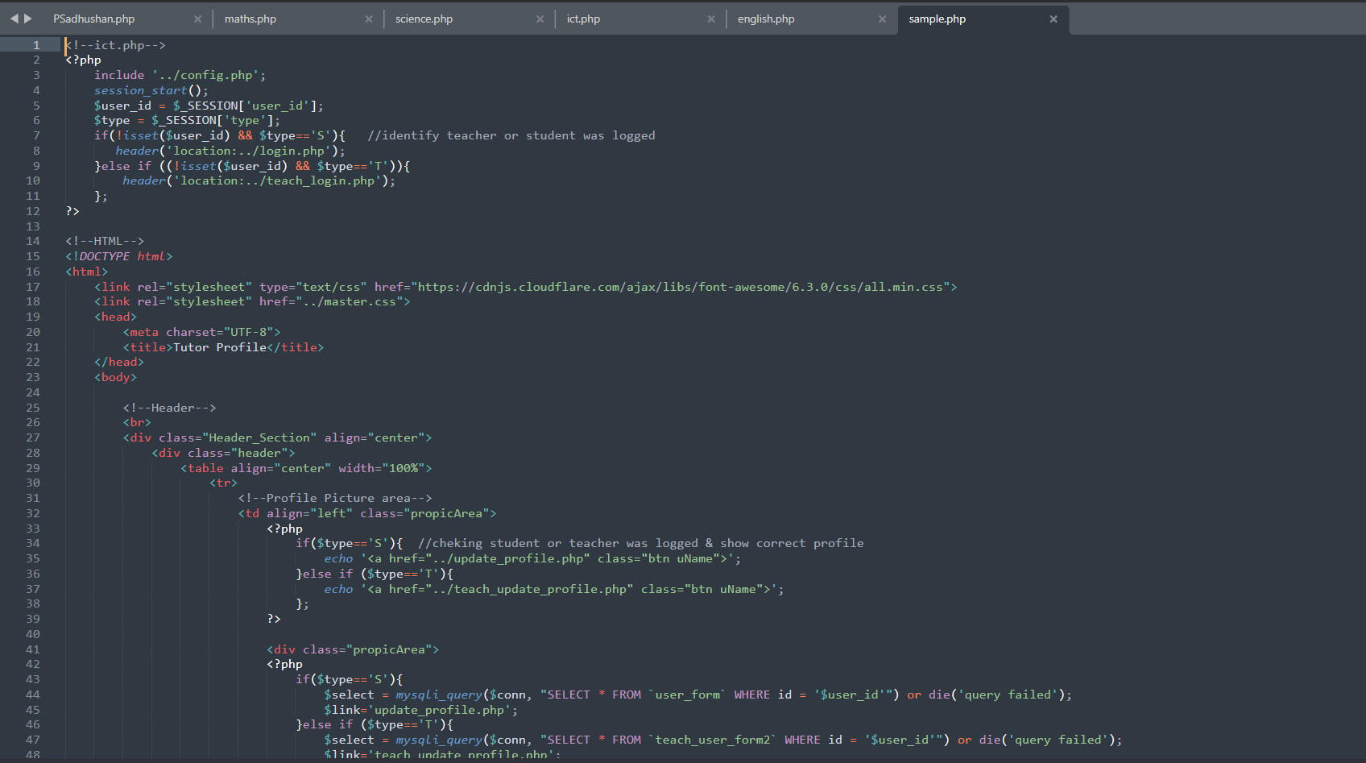

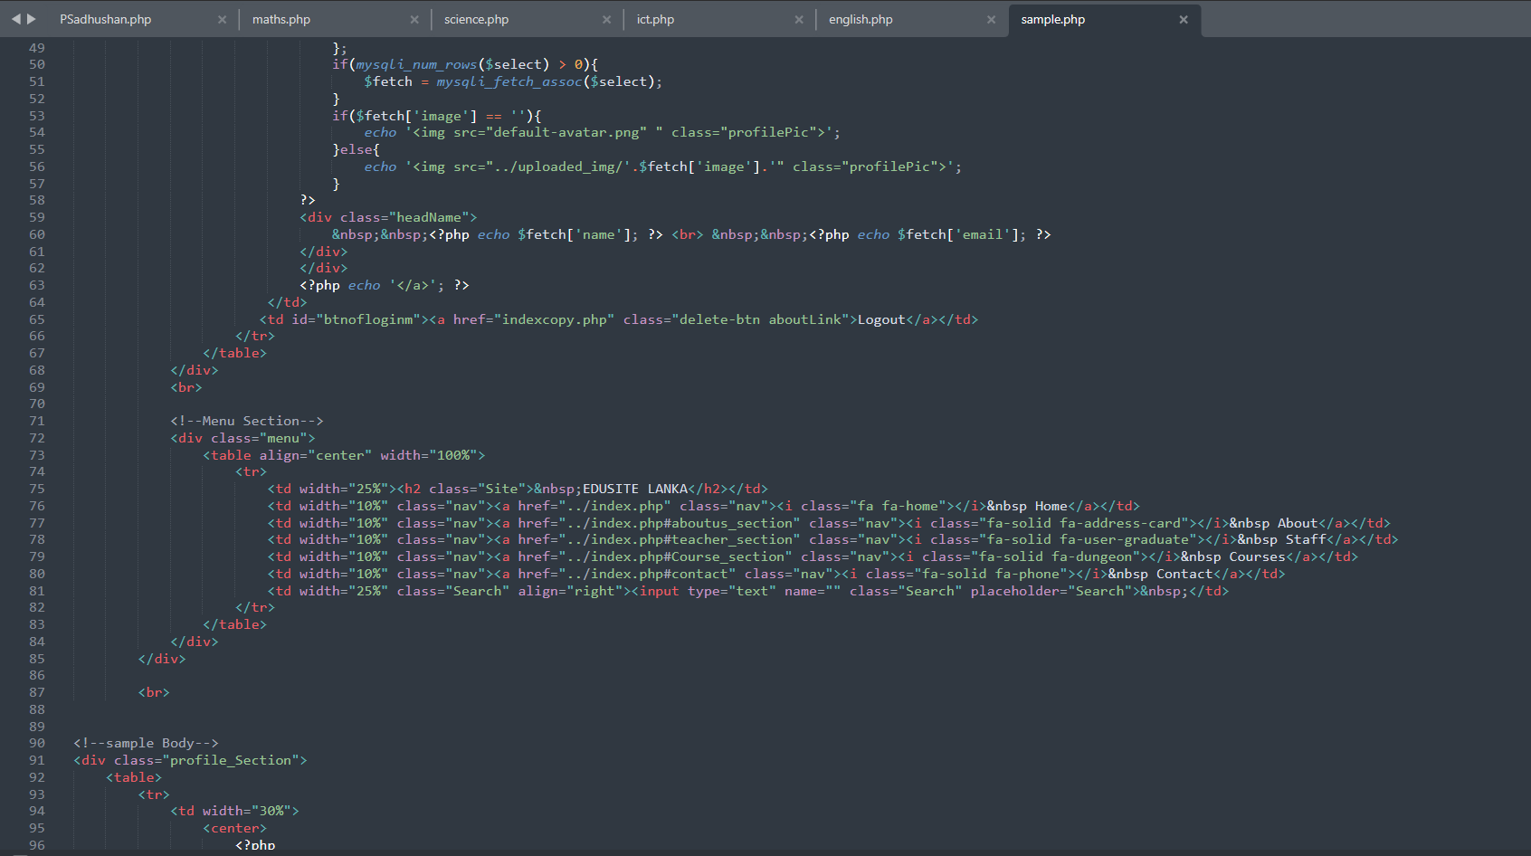

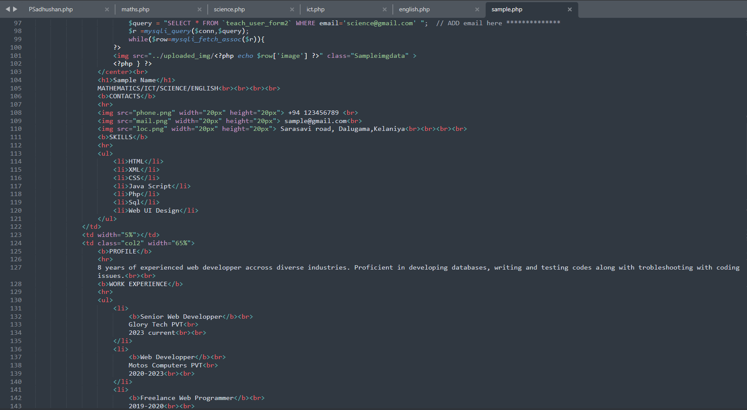

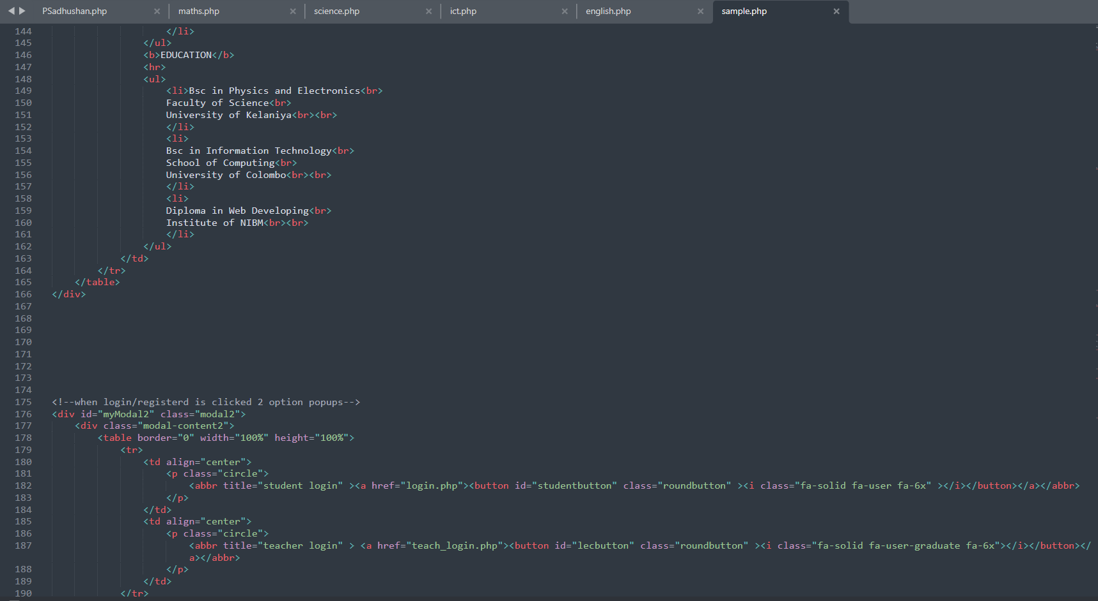

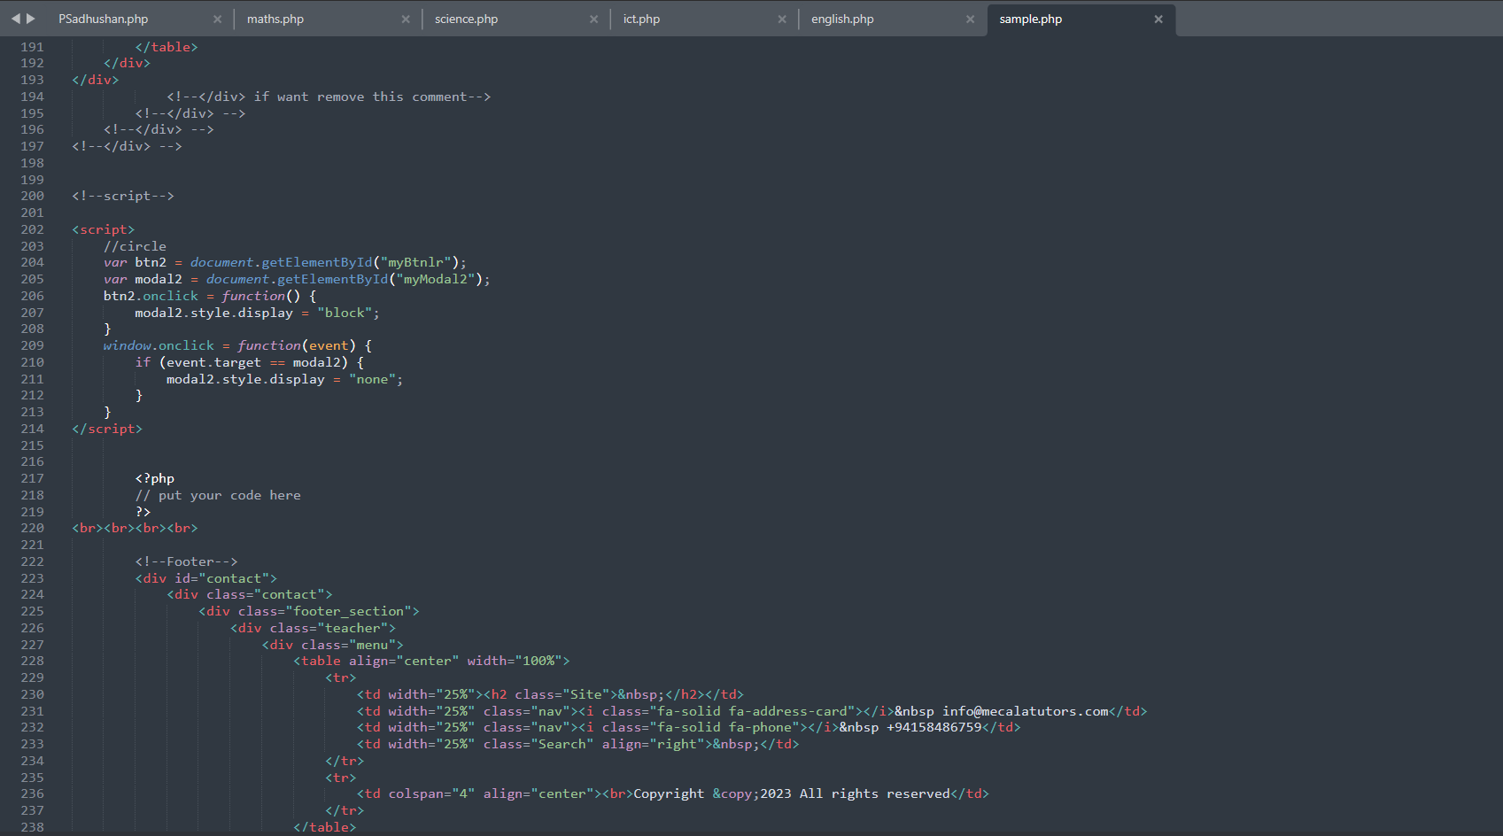

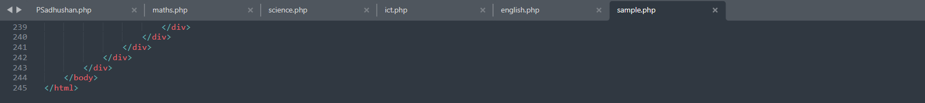

Tutor Update Profile Page

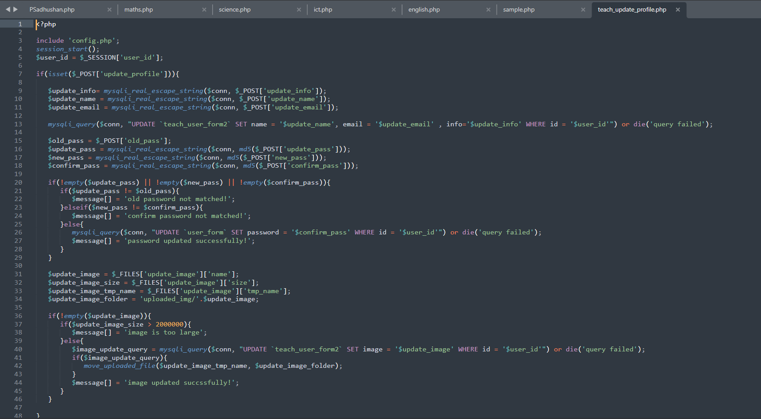

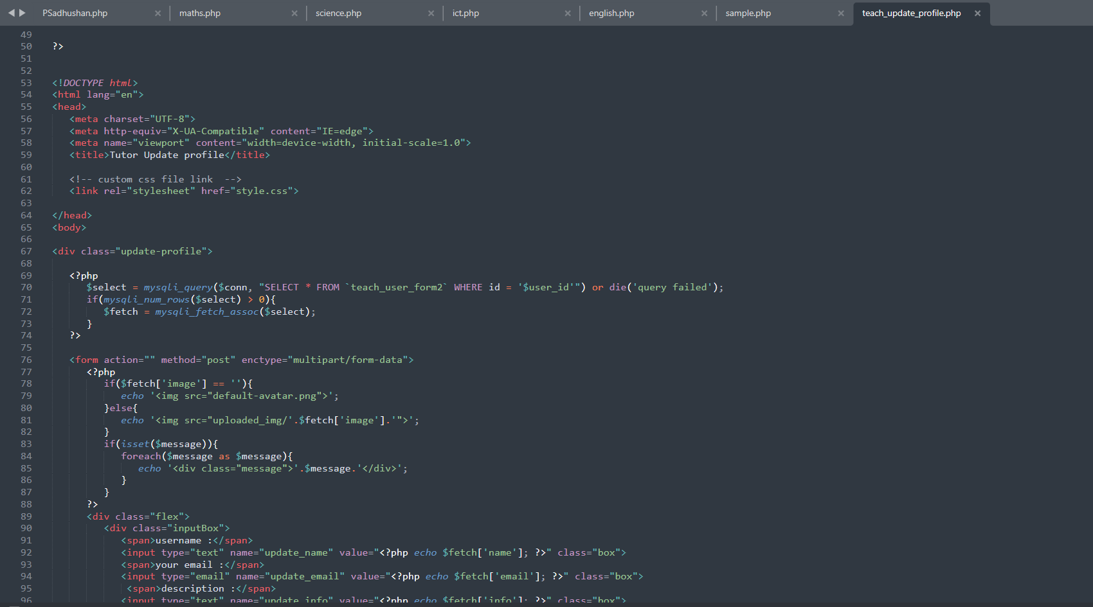

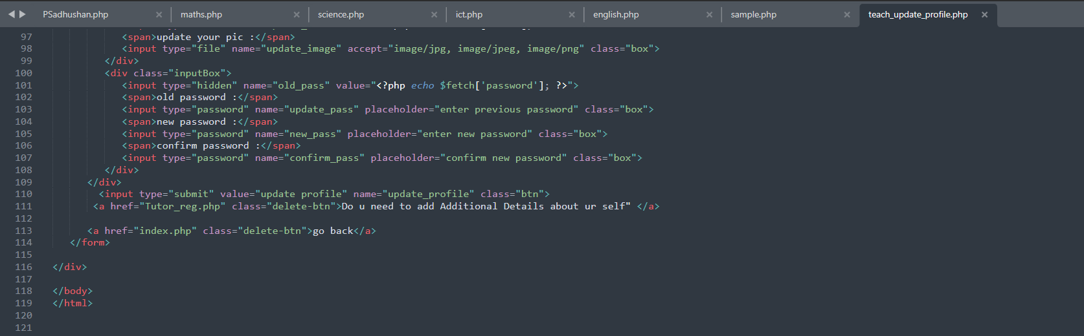

Student Update Profile Page

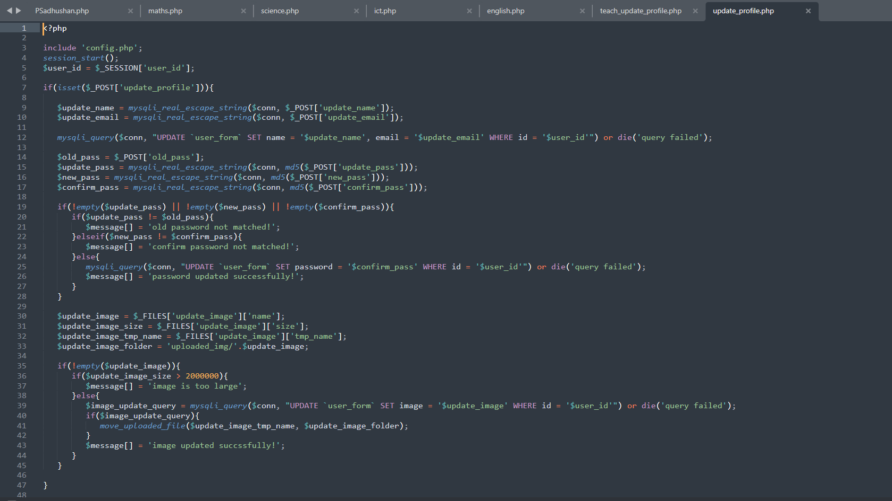

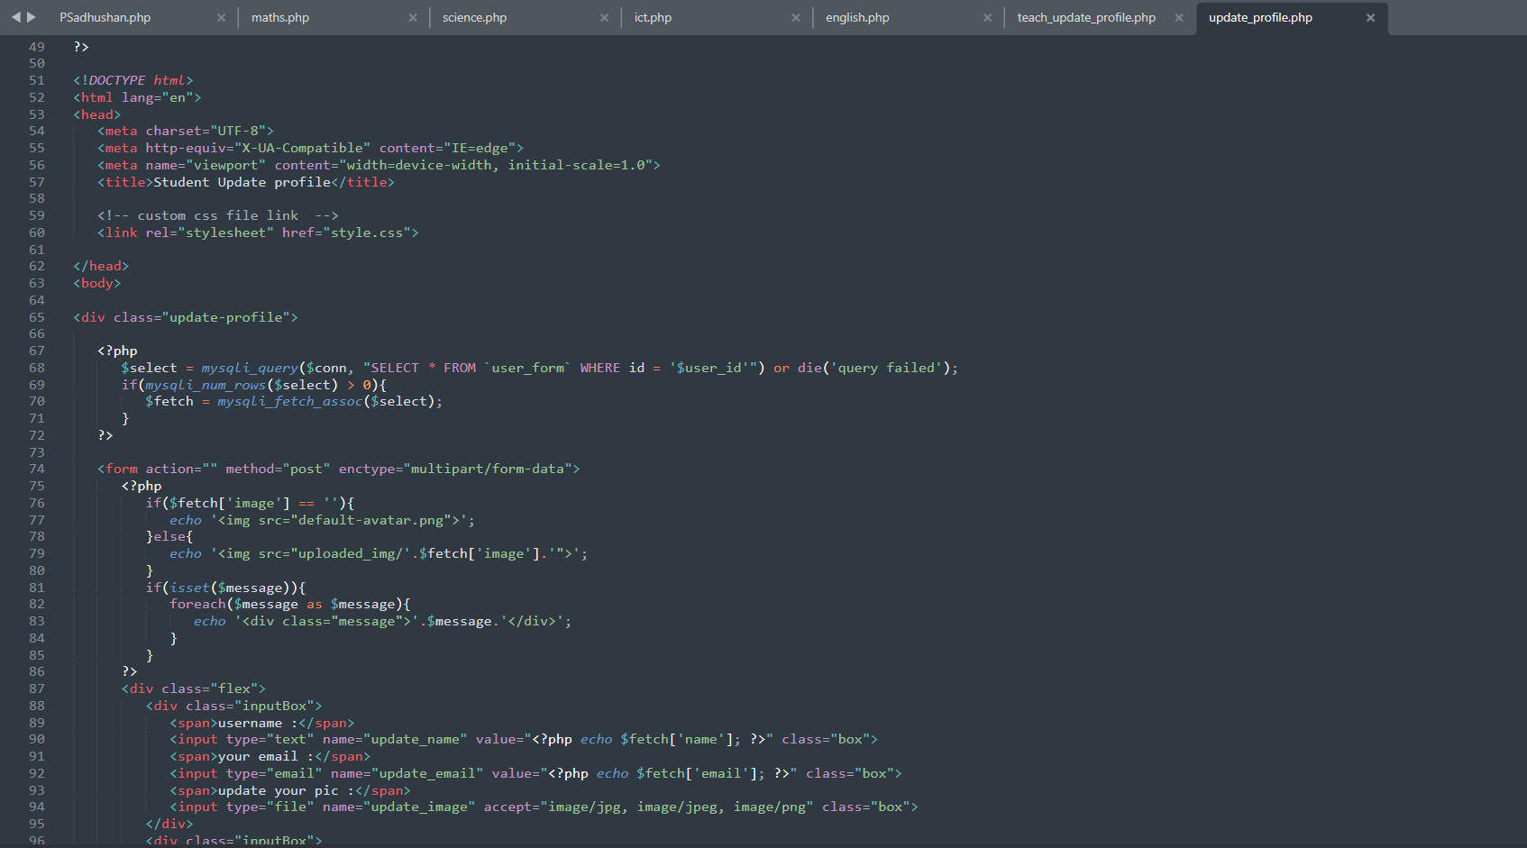

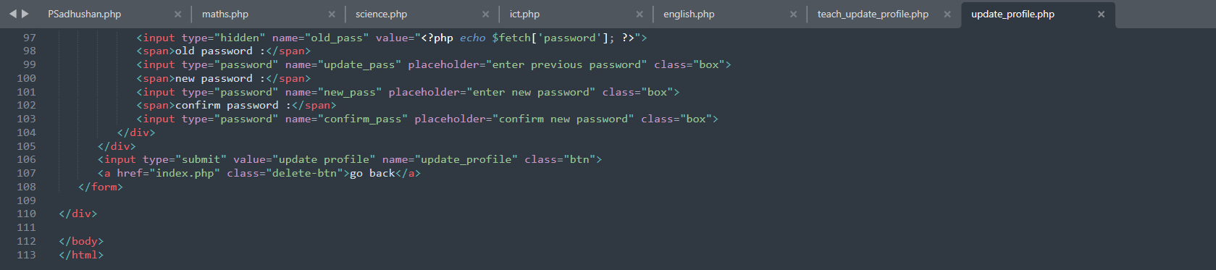

Tutor Registration Form Page

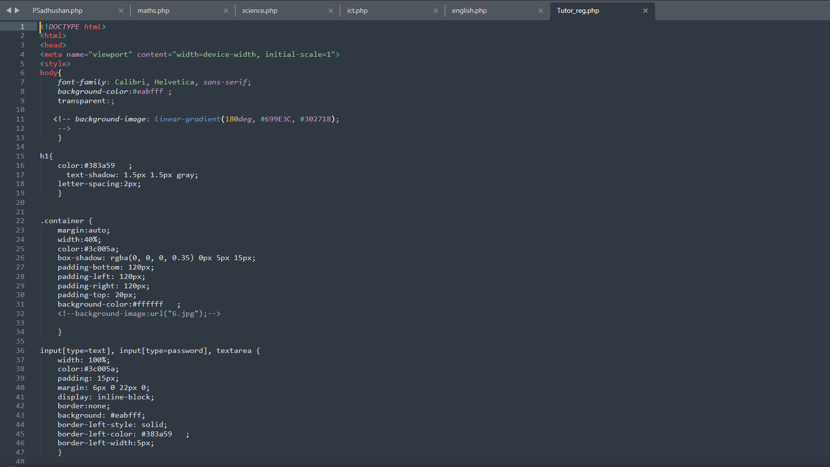

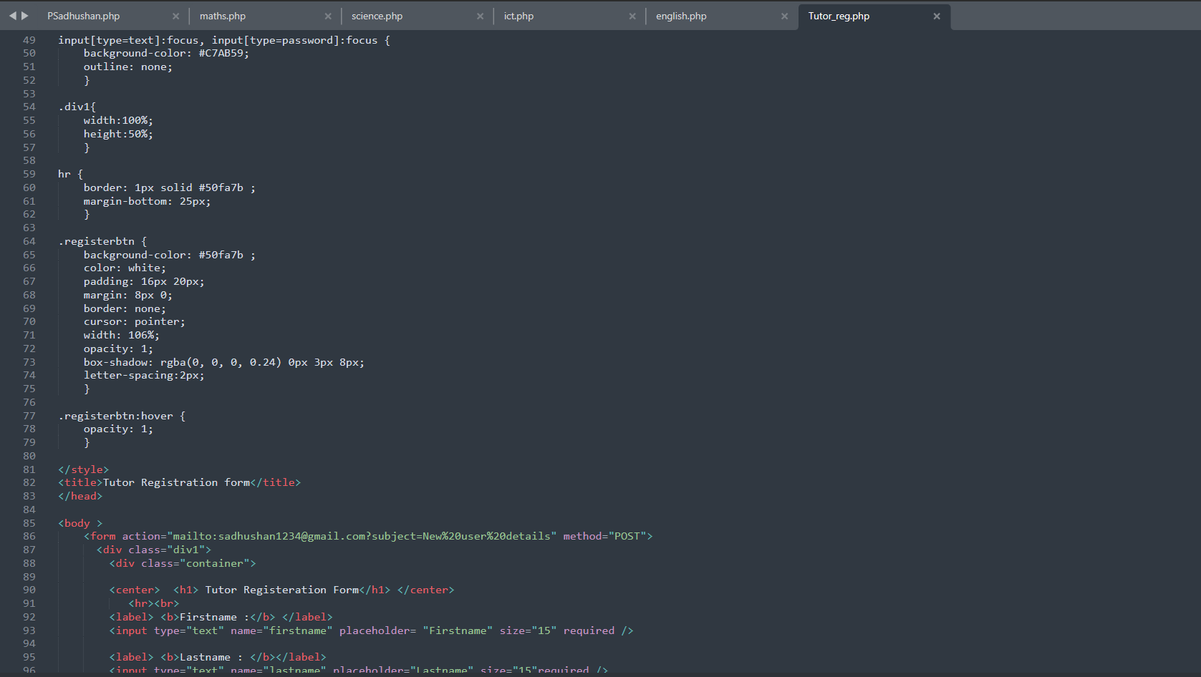

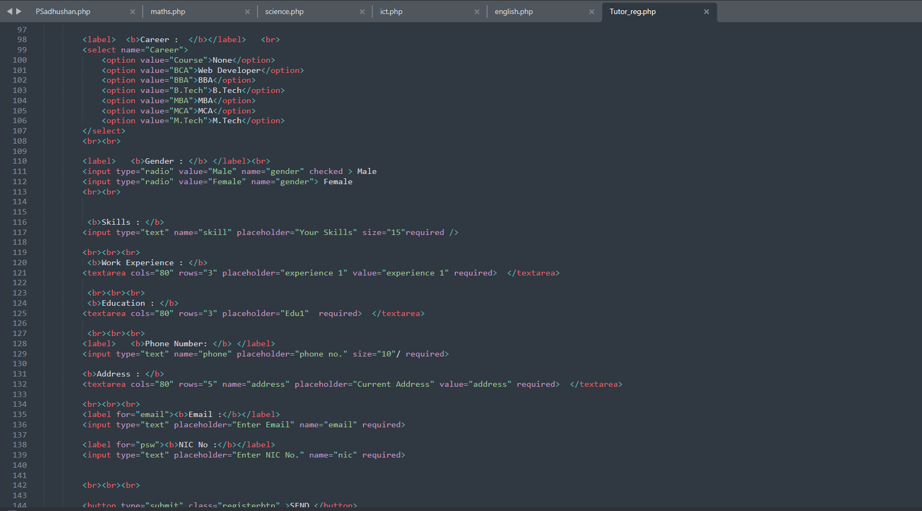

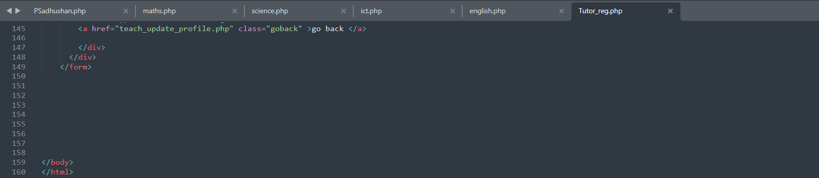

CSS codes for all pages

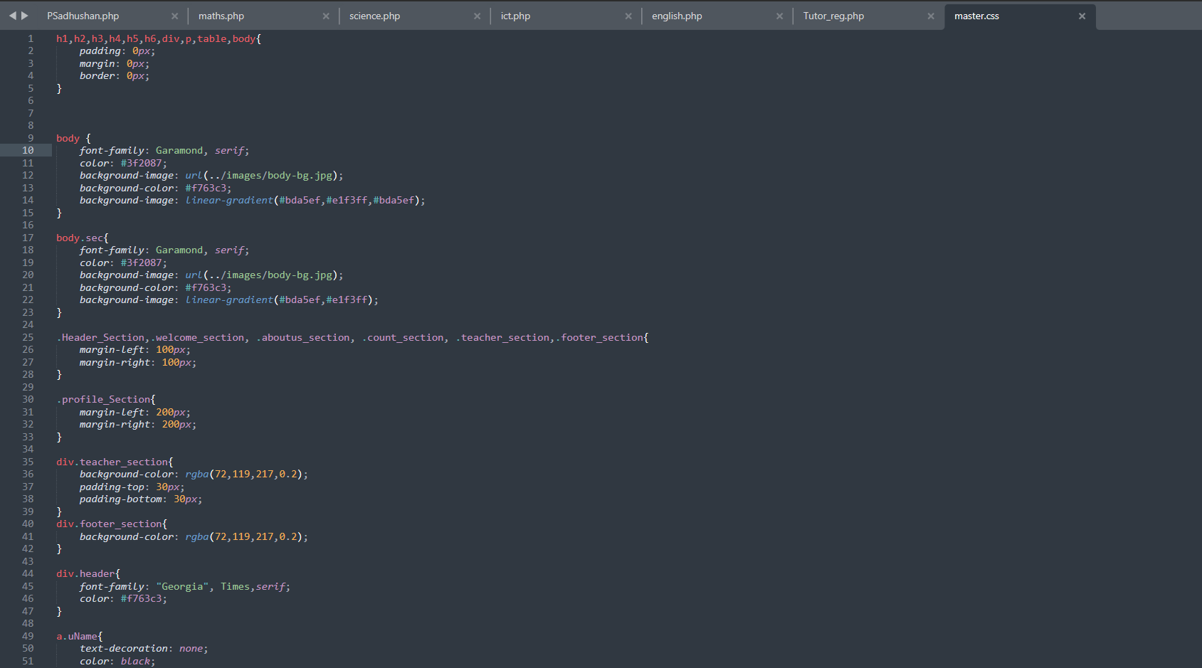

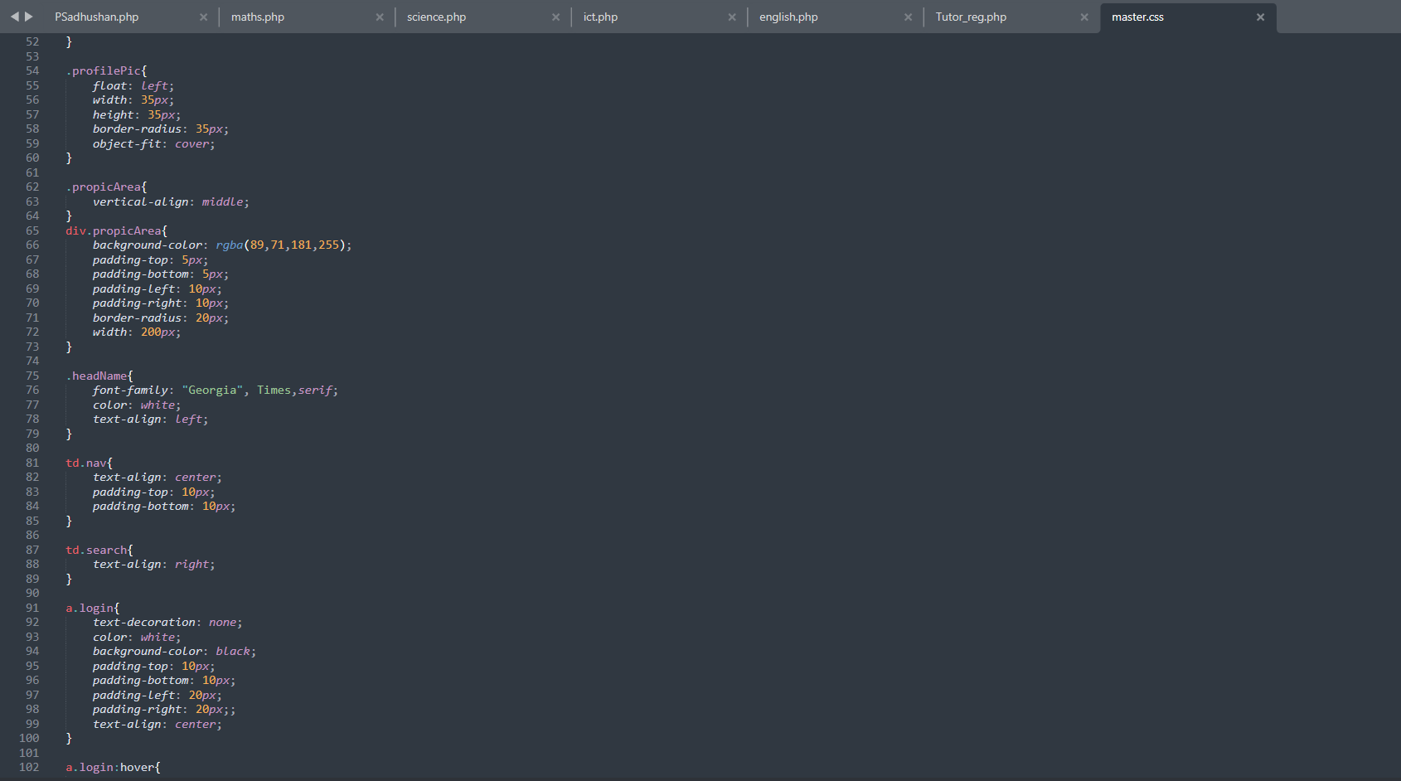

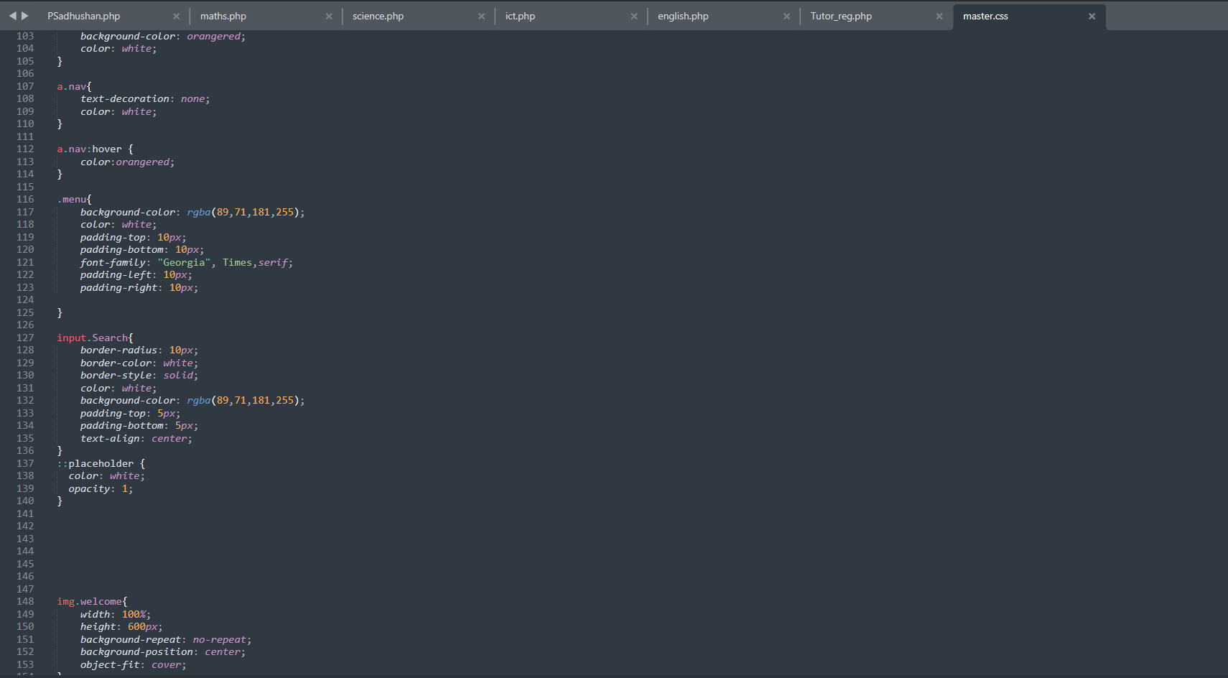

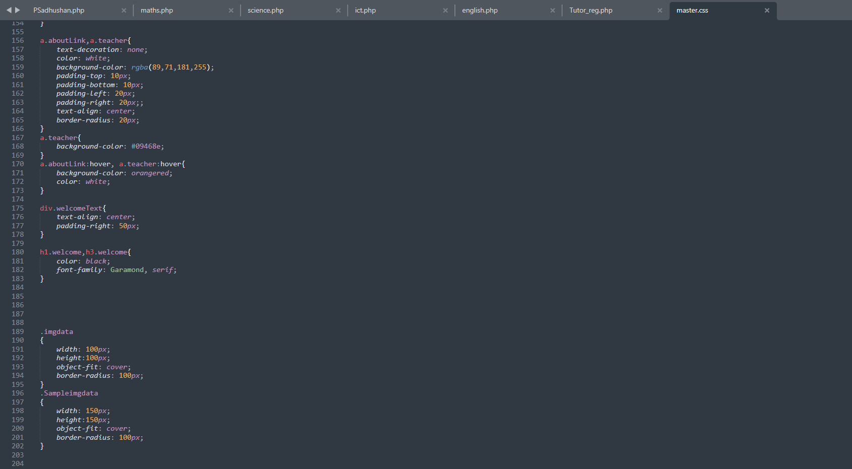

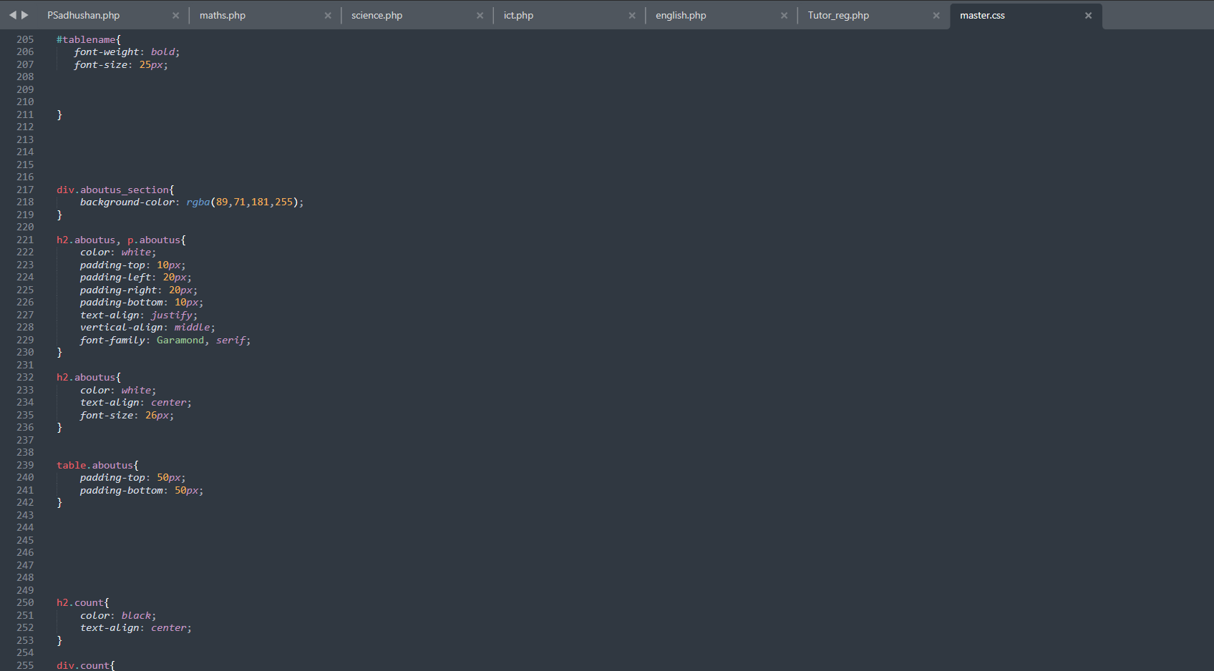

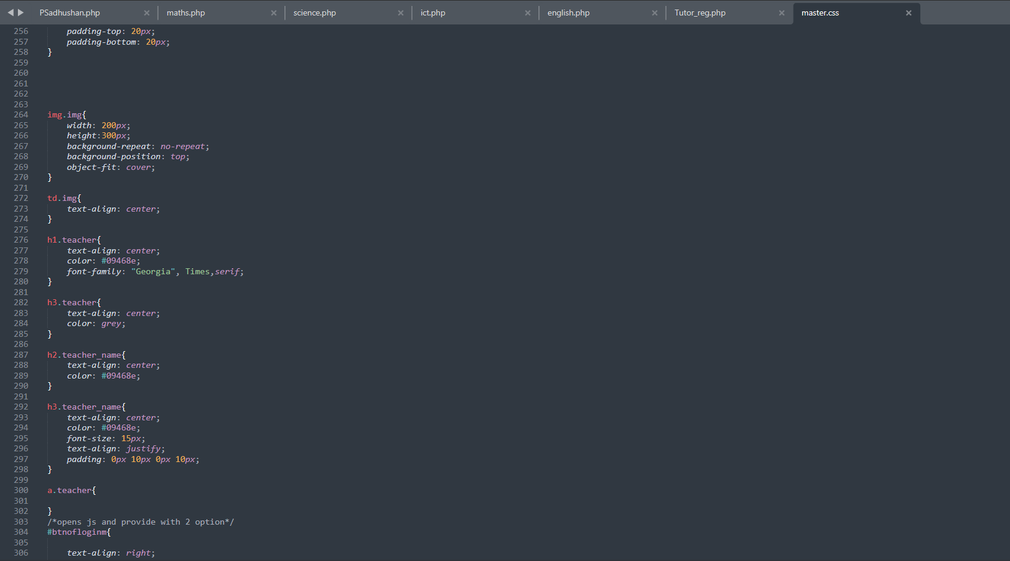

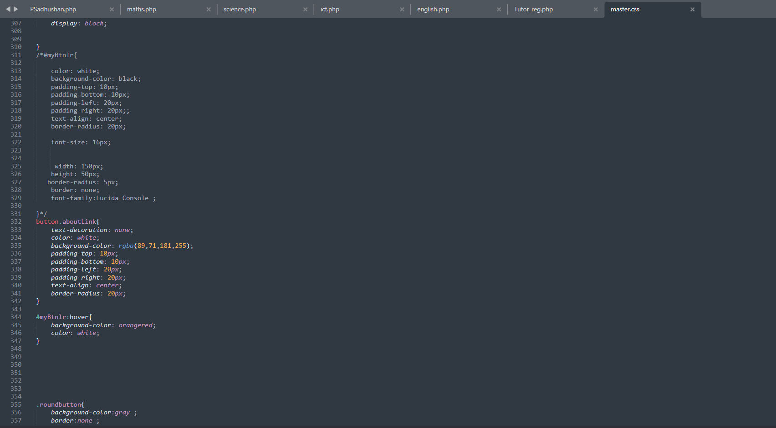

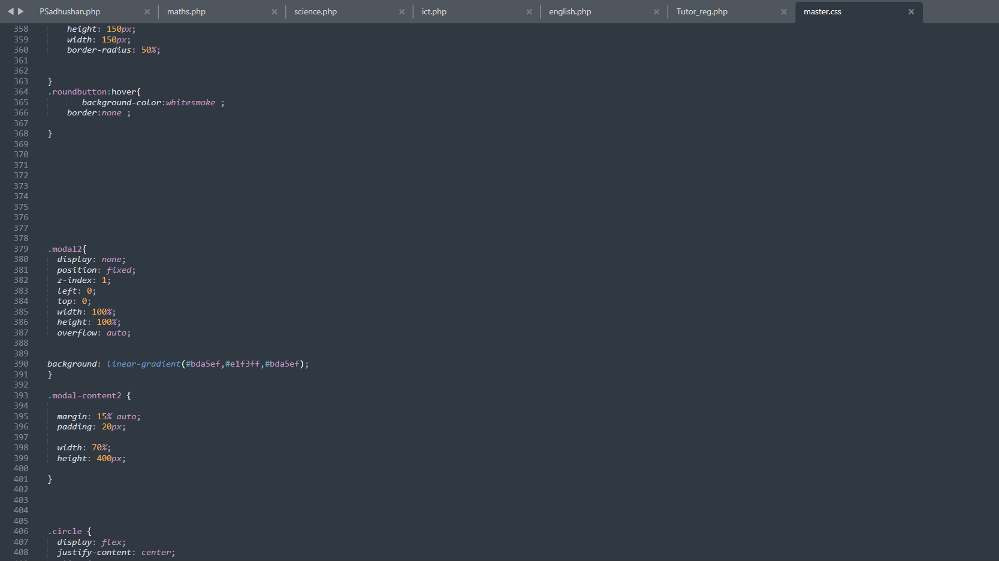

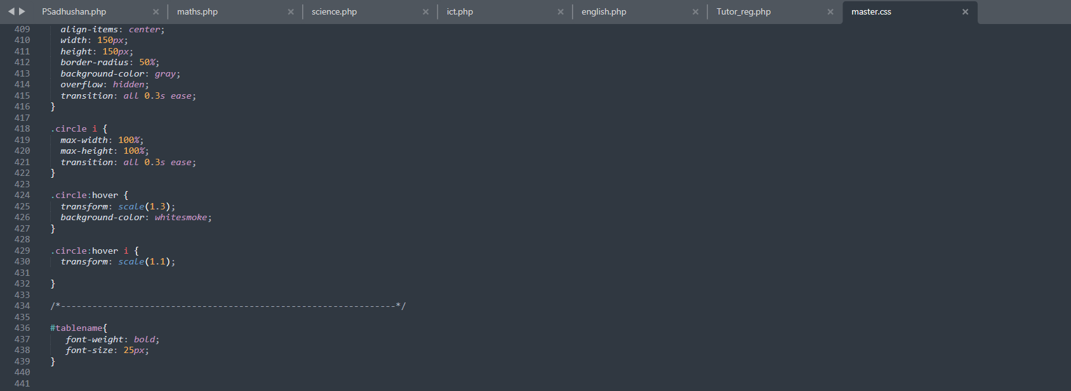

Config Page



SQL Code

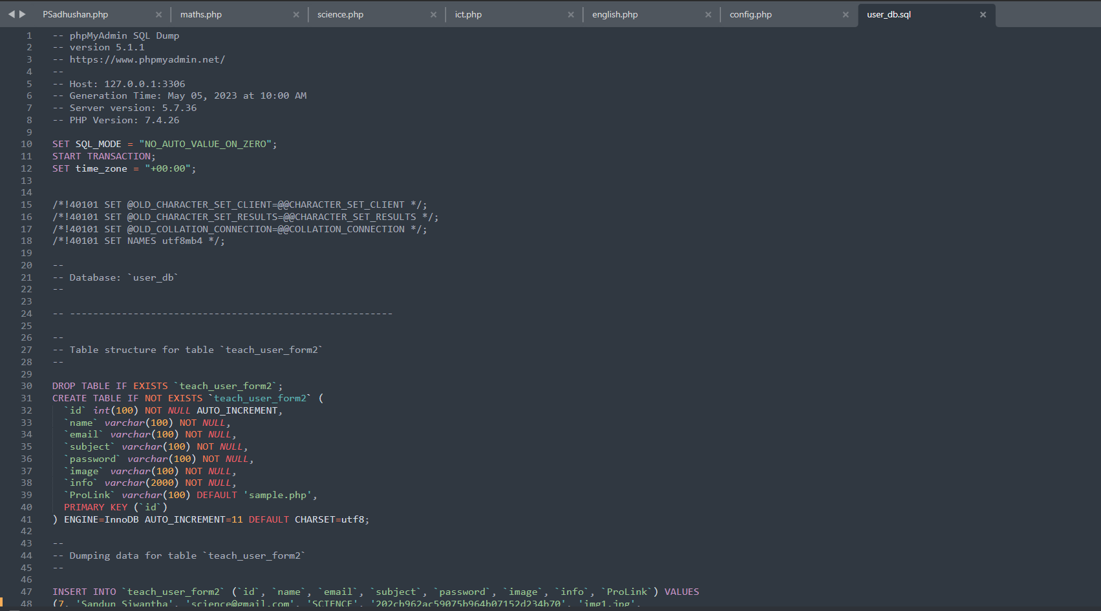

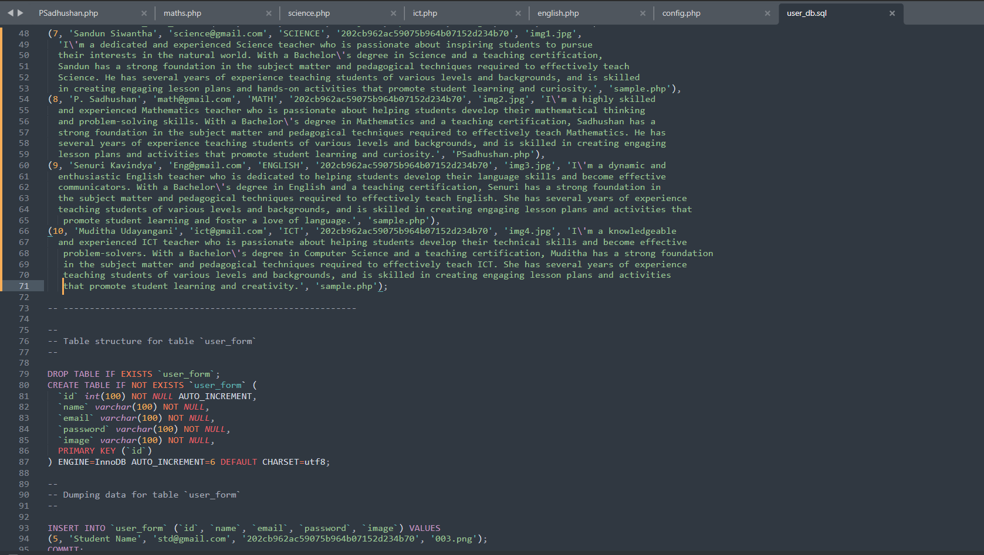

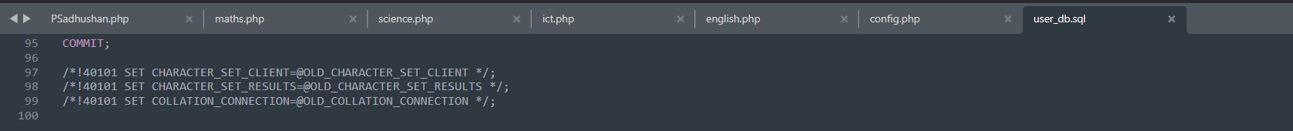

**TOOLS USED IN THE DESIGN AND DEVELOPMENT OF THE WEBSITE**

|  |  |
| --- | --- |
| **TOOL** | **USES** |
| HTML | Used in website creation to structure and format content |
| CSS | used in website creation to control the visual appearance and layout of web pages |
| JAVASCRIPT | Used in website creation to add interactivity, dynamic behavior, and client-side functionality, enhancing user engagement, and enabling the development of interactive web applications. |
| PHP | Used in website creation to handle server-side processing, database interactions, and dynamic content generation, allowing for the creation of dynamic and interactive websites. |
| www.freepik.com | used in get high-quality graphic resources, including icons, illustrations, and templates |
| www.sublimetext.com | Used for website development due to its powerful features, efficient code editing capabilities, and extensive plugin ecosystem, which enhance productivity and streamline the coding process. |
| github.com | Used for version control and collaborative development, allowing multiple developers to work on a project simultaneously, track changes, and easily manage code repositories. |
| netbeans.apache.org | Used for website development due to its comprehensive set of tools, code navigation features, and integrated support for multiple programming languages. |

**INITIAL PLAN VS. ACTUAL PLAN**

|  |  |
| --- | --- |
| INITIAL PLAN | ACTUAL PLAN |
| Make the page for a dark color theme | A light color theme is used to make the page |
| Create the form so that the database is updated and update the profile with that data | Manually update the profile by taking the data from the form for an email |
| Making a fixed footer with more details | made with a little detail with a scrollable footer |

**WORK CONTRIBUTION TABLE**

**Coordinated by,**

Back-end Development : Sandun

Front-end Development : Senuri

Database Handling : Sadhushan

Content Writing : Muditha

"We would like to extend our heartfelt appreciation and recognition to each member of our group who contributed their time, effort, and expertise to bring this website project to life. The success of this endeavor would not have been possible without the dedication and hard work of each team member. Their creativity, collaboration, and attention to detail have truly elevated the quality of this website. We would like to express our gratitude to Sandun, Sadhushan, Senuri, and Muditha for their invaluable contributions and commitment throughout the entire project. Their combined skills, professionalism, and unwavering determination have made this website a remarkable achievement. We are incredibly proud of our team and the remarkable work we have accomplished together."

|  |  |
| --- | --- |
| GROUP MEMBER | DESIGNED WEB PAGES |
| SANDUN | * Home page (Index.php) * Staff page (Staff.php) |
| SADHUSHAN | * Login page  1. Tutor login page (TeachLogin.php) 2. Student login page (Login.php)  * Register page  1. Tutor register page (Teach_Register.php) 2. Student register page (Register.php)  * Tutor Update profile page (teach_update_profile.php) * Student Update profile page (update_profile.php) |
| SENURI | * Tutor Registration form page (Tutor_reg.php) * Tutor profile page (Sample.php) |
| MUDITHA | * Subject pages  1. Mathematics page (Maths.php) 2. Science page (Science.php) 3. ICT page (Ict.php) 4. English page (English.php) |

**DETAILS OF GROUP MEMBERS**

**NAME : H.A.K.S. SIWANTHA**

**STUDENT NO : PE/2019/017**

**EMAIL : hakssiwantha@gmail.com**

**NAME : P. SADHUSHAN**

**STUDENT NO : PE/2019/013**

**EMAIL : sadhushan1234@gmail.com**

**NAME : A.A.M. UDAYANGANI**

**STUDENT NO : PE/2019/052**

**EMAIL : mudithaudayangani99@gmail.com**

**NAME : A.A.S. KAVINDYA**

**STUDENT NO : PE/2019/033**

**EMAIL : senurikav19@gmail.com**